
Cyber Defence
Assessment S1: Risk management strategy
Module Coordinator: John Curry
Marker: John Curry

Date of submission:
Number of words: 4900

Abstract
This report will analyse the cyber threats to an organisation named Pingu Services Ltd. and offer some mitigation strategies following a recent ransomware incident. Threats have been categorised into a few key areas: phishing, malicious files/ransomware, human insider threats, unpatched systems, supply-chain, and physical security threats; both general and specific to the organisation's business. The weakness assessment of Pingu shows a flat network, use of out-of-date software, a lack of segmentation on parts of their network, and poor educational use with their users (Victoria Bukky Ayoola et al., 2024).
To address these, we will propose a defence-in-depth strategy that employs layered technical, administrative, and physical controls that are developed and in accordance with trusted frameworks. This approach consists of enforcing strong access controls with multi-factor authentication, robust patch management and patch configuration management, network segmentation and monitoring, email/web filtering, endpoint protection, and legitimate backup processes. Security awareness training and insider-risk programs are also vital (Rios Insua et al., 2019). The strategy cites ISO/IEC 27001, NIST’s Cybersecurity Framework (Identify, Protect, Detect, Respond, Recover), and CIS Controls for a comprehensive overview of defence-in-depth. Lastly, Part 2 reviews an Immersive Labs exercises; this analysis is a case for continuous monitoring and audit logs because: log analysis proactively identifies security threats. The successful implementation of all measures listed here shall improve Pingu's resilience against future attacks (Roy, 2020).
Employee knowledge training and insider-risk programs are also essential. The strategy coverage is guided by all three, ISO/IEC 27001, NIST's Cybersecurity Framework (Identify, Protect, Detect, Respond, Recover), and the CIS Controls to ensure coverage is considered holistically. Lastly, where continuous monitoring comes into play, following through with the measures will also guarantee to strengthen Pingu’s resilience to any future attacks (NIST, 2018).

Contents
Abstract 2
Contents 2
Introduction 3
Organisational Overview 4
Threat Landscape 5
General Threats 5
Industry Specific Threats 5
Vulnerability Assessment 6
Boundary Firewall (Watchguard Firebox M390) 6
Cisco Meraki Switches 6
Servers 6
Windows Server 2016 R2 6
Endpoint Devices 7
Microsoft 365 E5 7
Physical and Environmental Security 7
Human Factor Vulnerabilities 7
Compliance Risks 8
Defence-in-depth mitigation strategy 8
Log Analysis 10
Conclusion 30
References 32

Introduction
The very expansion of digital infrastructure in the public and private sectors has radically altered the organizational dynamics of how organizations function, simultaneously increasing the level of complexity of the threats that they encounter (Selvakumar, 2022). This report encompasses the case study of Pingu Services Ltd., a UK-based organization recently acquired by Capital Science Group (CSG), with the perspective of assessing the cybersecurity threats that it encounters and recommending mitigation strategies. The aim is to create a comprehensive defence mechanism that integrates policy, technology, and people to safeguard legacy and emerging systems (Obitade, 2019).
Pingu Services is ISO 27001 certified and deals with sensitive systems and data, which is an attractive attribute that made it an easy target for acquisition by CSG, a larger public listed company that deals in environmental consultancy. Integrating after such acquisitions often brings along new threat surfaces, especially while consolidating different IT infrastructures and access control systems (Alaranta and Henningsson, 2008). The consolidation of Pingu's legacy systems, such as Windows Server 2016 and Ubuntu test environments, with CSG's modern cloud infrastructure based on Microsoft 365 E5 licenses, requires a thorough assessment of threats and vulnerabilities.
A layered approach to cybersecurity is essential for proactively managing risk. The "defense-in-depth" approach is worthy of thoughtful application whether segmented, secured, monitored, or managing incidents (Waheed et al., 2024). Insider threats should also be considered because the previous owners will be leaving the organization, and they will assume the roles in development, finance, and sales. Given the same security clearances and overall organizational "flat" structure, it is debatable whether a secure separation of duties will be able to be maintained after acquisition (Alsowail and Al-Shehari, 2021). These topics arose during Pingu's ransomware incident, which used a malicious PDF attachment within a recruitment email, which also qualified organizational vulnerability to social engineering and reinforced email filtering, user training, and endpoint protection (Gallegos-Segovia et al., 2017).
Equally important to monitoring and analysing security events is the ability to observe and react to threats in real time. This report integrates the findings from my own Splunk laboratory work; with realistic examples of advanced searching, dashboard visualizations showing how log analysis technology can help support our first line of defence (Pan, 2024). A platform such as Splunk provides comprehensive visibility into all network and endpoint activity; meaning an organization can not only monitor, but also proactively detect threats and reduce mean time to response (MTTR) (Pan, 2024). Each of these features correspond to NIST Cybersecurity Framework's 'Detect' and 'Respond' and are integral to an agile and modern cyber defence strategy (Rosenberg et al., 2023).
The report itself is comprised of key sections that look at Pingu's threat landscape, assess current weaknesses, and provide recommendations both around technology and procedures to enhance existing defences. It concludes with the way to weave practical experience of labs with theoretical defence planning; with the net result being a meaningful plan to defend Pingu Services during and especially after the post-acquisition transition (PwC, 2021).

Organisational Overview
Pingu Services Ltd is a private limited company based in the UK with offices in Warminster and Salisbury. Pingu Services has 75 staff which specialise in software and hardware development, they maintain an ISO 27001 certification for its information security management system (ISMS). CSG acquired Pingu Services to expand into sensitive systems and consultancy services.
Integration has seen several changes:
- Reduction of support staff through voluntary redundancy.
- Relocation of administration and support activities to CSG headquarters at Reading.
- Restricting security clearances to the absolute minimum of essential personnel.
- Centralization of project management with rotating personnel between offices.
Stays on-site at Salisbury for development teams.
Major infrastructure at Pingu is:
- WatchGuard Firebox M390 perimeter firewall.
- Several Cisco Meraki switches.
- Several Dell PowerEdge servers with Ubuntu and Windows Server 2016.
- End-user systems ranging from Dell Inspirons to MacBook Pros.
The infrastructure underpins the operations of Pingu and hosts general corporate services along with development/test environments.

Threat Landscape

General Threats
Ransomware: As demonstrated by a previous attack via an infected CV PDF, ransomware poses a severe threat. Three days were required for recovery from backup, which reflects deficiencies in real-time recovery and containment (Bauer, 2019).
Phishing and Spear Phishing: During periods of staff vacancies and hiring, there is a greater likelihood of successful phishing attacks (Lenaerts-Bergmans, 2023).
Insider Threats: While clearance levels have historically alleviated this threat, structural changes can increase the possibility of intentional misuse by disgruntled employees or accidental misuse (IBM, 2021).
Shadow IT and BYOD Threats: A heterogenous collection of devices (with unmanaged Macs) results in difficulties standardising security policy (P., 2021).
Unpatched Systems: Windows Server 2016 is approaching end-of-life (October 2025) and will soon be missing critical security patches (Office, 2025).

Industry Specific Threats
IP Theft: Pingu's R&D in sensitive areas makes it a top target for corporate and nation-state spying (Cyberhaven, 2024).
Supply Chain Attacks: Since Pingu relies on third-party hardware and software, it is vulnerable to upstream compromises (Korolov, 2021).
Physical Intrusion: Internally controlled physical security (i.e. CCTV and alarm systems) is without independent oversight, an open invitation to manipulation (National Center for Education Statistics, 2019).
Compliance Risks: There is a requirement to maintain ISO 27001 certification through adherence to stringent controls, especially during restructuring (Anwita, 2023).

Vulnerability Assessment
A detailed vulnerability assessment is necessary to determine the security posture of Pingu Services. The below assessment categorizes vulnerabilities by type of system, using CVE databases, CIS Controls, and NIST CSF (Hafizhan Irawan, Alva Hendi Muhammad and Nasiri, 2024).

Boundary Firewall (Watchguard Firebox M390)

- Firmware Patching: Unpatched firmware creates critical vulnerabilities (e.g., CVE-2022-26318) (Acharya, Joshi and Gouda, 2010).
- Misconfigured Rulesets: Overly permissive firewall rules or outdated ACLs can allow unauthorized ingress/egress (Acharya, Joshi and Gouda, 2010).
- Inadequate Segmentation: Firewalls must ensure strict segmentation of development/testing and production environments (Acharya, Joshi and Gouda, 2010).
Mitigation:
Regular firmware updates, audits of firewall rules, and enforcing zero-trust practices (Laliberte, 2024).
Cisco Meraki Switches
- Lateral Movement: Flat LAN topology offers broad internal access (Trabelsi and El-Hajj, 2025).
- MAC Flooding & ARP Spoofing: Switches are vulnerable without dynamic ARP inspection and port security (Trabelsi and El-Hajj, 2025).
Mitigation:
Allow port-based security, VLAN separation, apply 802.1x authentication (Zhang et al., 2015).
Servers
- Dell PowerEdge R360
- Privilege Escalation: Old packages or poor Sudo policies (Zhong et al., 2017).
- Open Ports: Typical misconfigurations that leave SSH, FTP, or other irrelevant services exposed (Zhong et al., 2017).
Mitigation: Apply CIS hardening benchmarks for Ubuntu, use automated vulnerability scanners like OpenVAS (Muharrom and Saktiansyah, 2023).
Windows Server 2016 R2
- End-of-Life (EOL): Support is ended in 2027; vulnerabilities such as CVE-2021-34527 (PrintNightmare) are still present (Yin et al., 2022).
- Group Policy misconfigurations can allow lateral movement and privilege escalation (Yin et al., 2022).
Mitigation: Plan migration to Windows Server 2022. Use regular patching via WSUS or SCCM (Kadry and Joumaa, 2025).
Endpoint Devices
- BYOD Risks: OS and hardware diversity causes consistency problems with updates (Szefer et al., 2014).
- USB port vulnerabilities and local administrator rights: Inadequate control can result in exposure to insider or physical attacks. Mitigation: Enforce device hardening requirements, use MDM solutions (e.g., Intune) for compliance (Szefer et al., 2014).
Microsoft 365 E5
- Email Spoofing and Phishing: Despite advanced tools like Defender and ATP, poorly configured policies open loopholes (Chandrasekaran, Chinchani and Upadhyaya, 2006).
- Excessive Permissions: Over-privileged accounts remain one of the most critical security issues (Chandrasekaran, Chinchani and Upadhyaya, 2006).
Mitigation: Apply Microsoft Secure Score recommendations, activate MFA, limit access to confidential SharePoint sites (Karim et al., 2024).
Physical and Environmental Security
- Remotely Accessible CCTV: Possibly a backdoor if credentials are weak or unencrypted (Koca, 2024).
- Site Access Control Loopholes: With fewer employees on site, there is a greater chance of tailgating or unauthorised access (Koca, 2024).
Mitigation: Enforce stricter badge and biometric controls, rotate access credentials periodically (Sung Hoon Lee et al., 2023).
Human Factor Vulnerabilities
- Untrained Staff: Less on-site staff may lack situational awareness or cyber hygiene (Udochukwu ThankGod Ikechukwu Igwenagu et al., 2024).
- Email Handling Procedures: A known ransomware vector; demands mandatory training on awareness (Udochukwu ThankGod Ikechukwu Igwenagu et al., 2024).
Mitigation: Periodic training, phishing exercises, security awareness certifications (e.g., Cyber Essentials Plus) (GOV.UK, 2016).
Compliance Risks
- ISO 27001 Maintenance: Document control and compliance activities can take a backseat with reductions in staff (Udochukwu ThankGod Ikechukwu Igwenagu et al., 2024).
- GDPR Violations: Since personal HR and development data is being stored, breach impact is high (Udochukwu ThankGod Ikechukwu Igwenagu et al., 2024).
Mitigation: Conduct annual audits, appoint Data Protection Officers (DPOs), maintain Records of Processing Activities (RoPA) records (ICO, 2023).

Defence-in-depth mitigation strategy
To protect Pingu Services, we recommend a defence-in-depth approach – layering multiple security controls so that if one is compromised, others still provide protection (CISA, 2016). This layered approach (people, technology, and processes) gives you broad coverage across the enterprise. Key elements of the strategy include:
Network Segmentation and Access Control: Redesign the flat network as segmented zones (e.g. separate user, development, and production networks) using VLANs and firewalls. Sensitive systems must be on protected subnets (Salah, Elbadawi and Boutaba, 2012). Implement granular access control lists to limit lateral movement. This enforces the principle of least privilege at the network level. It also supports ISO 27001 Annex A controls for secure network design. Firewalls and network IDS/IPS appliances can enforce segmentation while scanning for malicious traffic (Malatji, 2023).
Identity and Access Management: Enforce authentication and authorization strictly. Use Multi-Factor Authentication (MFA) for all administrator and remote access, making stolen credentials largely useless (following NCSC guidelines). Only grant user accounts the privileges they need to perform their role (the CIS principle of least privilege) (Abbott and Patil, 2020). Administrator accounts should be on jump boxes or dedicated management workstations, not on general-purpose machines. Implement account lockout and password complexity policies to defend against brute-force attacks (Najafabadi et al., 2014).
Email and Web Security: For the phishing attack vector, employ robust email filtering (SPF/DKIM/DMARC anti-spoofing, sandboxing of attachments) and web filtering (DNS filter or proxy to block known malicious sites). As NCSC recommends, content-based filters and URL analysis help "make it difficult for attackers to locate your users". Mandate scanning of incoming emails for malicious attachments (especially PDFs). Look at the use of a mail gateway that quarantines suspicious content (Almomani et al., 2013).
Endpoint Protection and Configuration: Implement existing endpoint protection (antivirus/EDR) on all endpoints (Windows, Mac, mobile). Make sure such tools enable real-time scanning and behavioural monitoring for malware. Implement application whitelisting on high-risk endpoints where feasible. Enforce secure configurations: disable unnecessary services, apply least-privilege on user endpoints, and enable firewalls on endpoints. Use CIS Benchmarks for secure configurations. Periodically audit compliance with these configurations (Kafi and Akter, 2023).
Patch Management and Vulnerability Remediation: Implement an official patch management procedure (CIS Control 4). Test and deploy all substantial operating system, application, and firmware patches. Perform weekly or monthly vulnerability scanning to identify missing patches and use a risk-based strategy to remediate high-priority vulnerabilities first. Keeping software up to date closes the openings that poor cyber hygiene exploits. This also must be done for third-party components: use a Software Bill of Materials (SBOM) to track library versions and implement vendor notices (Nappa et al., 2015).
Logging, Monitoring, and Incident Response: Deploy a Security Information and Event Management (SIEM) solution such as Splunk to gather and analyse endpoint, server, network device, and application log activity. Utilize the skill learned in Immersive Labs Splunk series (i.e., Splunk Basics: Data Sources, Search, Advanced Searching, and Dashboards & Visualization) to establish log gathering from diverse sources such as Slack, VPNs, and operating systems to bring visibility in one location. As demonstrated in the "Demonstrate Your Skills" lab and Part 2 of the same activity, targeted searches such as those on Slack logs can find malicious communication or insider threats (Ampel et al., 2024).
Utilizing the Search Processing Language (SPL) of Splunk, create use-case based alarms for such anomalies as unauthorized login, unusual data transfers, or executing prohibited binaries. This agrees with the belief of CrowdStrike that log analysis is at the core of proactive threat detection and makes NIST Cybersecurity Framework's Detect and Respond capabilities possible (Zhang et al., 2017).
To enable detection to work, apply best practices in NIST SP 800-61 and ISO 27035 to guide your incident response workflows. By having a thoroughly defined, pre-planned response workflow, your team can respond rapidly and effectively when Splunk alerts triggers, so threats are contained and cleaned up with minimal impact (Preuveneers et al., 2020).
Data Protection and Backup: Encrypt data both in transit and at rest. Implement full-disk encryption on laptops and encrypted communications (TLS). Critical files (databases, designs) should be backed up at regular intervals, with offline immutable backups stored off-site. In this way, restoration from ransomware is achievable without paying ransom. Backup testing is required. These measures activate NIST CSF's Recover function and ISO 27001's business continuity dimension. Ensure a well-defined backup retention policy and verify backups integrity (Roy, 2020).
Supply Chain and Third-Party Risk Management: Implement a supplier vetting process. Require security attestation (e.g. SOC 2, ISO 27001 certification) from critical vendors. Monitor vendor notices (especially for components in critical systems) on a regular basis and maintain a Software Bill of Materials (SBOM) of software dependencies. This mitigates supply-chain risks by providing more visibility into upstream risks. Apply NCSC's supply chain guidance to enact controls (e.g. code signing, dependency scanning). Ensure all third-party access is logged and access is revoked as soon as services are rendered (Roy, 2020).
Security Awareness and Training: Provide all personnel with regular security training (CIS Control 14). Train users to be aware of phishing (following NIST and NCSC guidelines) and the requirement to report suspicious messages. Foster a no-blame reporting culture so that personnel report incidents in a timely manner. For technical personnel, train on best practices for secure coding and configuration management, reducing the insider-error risk. Conduct regular phishing simulation exercises to test and refresh employee awareness (Zhang et al., 2021).
Physical Security Controls: Strengthen physical security to complement cyber defence. Install card or biometric access controls on offices and server rooms. Implement CCTV monitoring of key areas. Locking workstations when unattended and escorting visitors. Network closets should be secured, and all active network jacks should be approved and labelled. This combination of physical and cyber security is promoted by CISA to provide an overall defence. Even when there are electronic safeguards, an intrusion where the insertion of a malicious device represents a cyber threat (Ampel et al., 2024).

Log Analysis
What is Splunk?
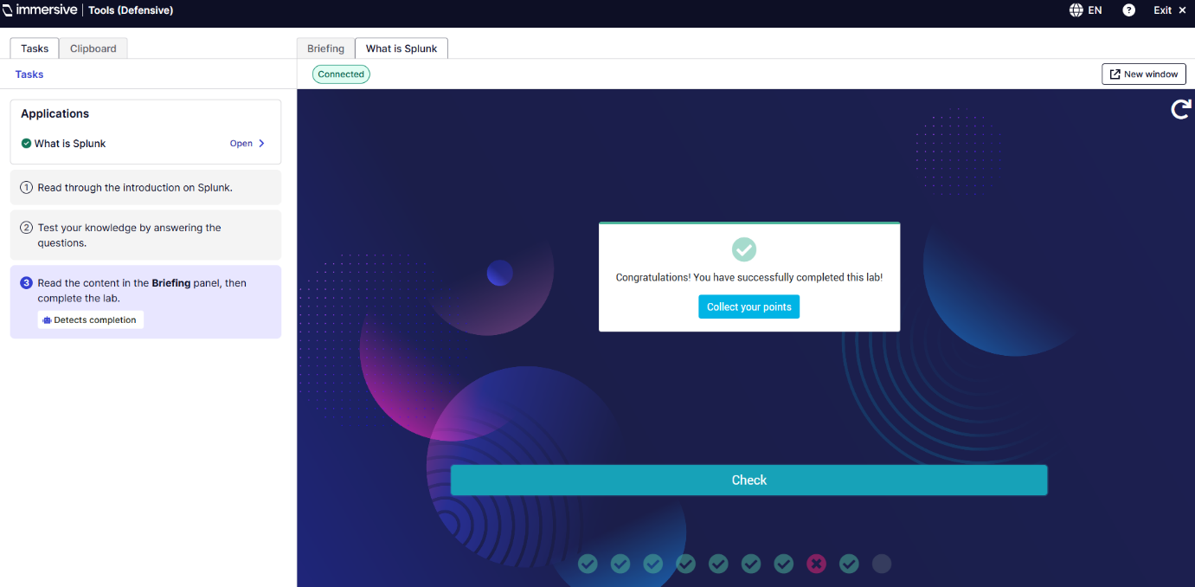

Objective: This first Lab is to help understand Splunk’s architecture. Its role in Security information and event management (SIEM) and Splunk’s ability to index machine data. It is multiple choice questions based on how Splunk works, how it’s useful to organizations and Splunk’s features which are: Indexing, Searching, Dashboards and visualizations, monitoring and alerting.
Outcome: I answered all the multiple-choice questions and learned the components and how the data is searched. I got all but one question corrects.
Relevance: This showcases understanding for how Splunk fits into a wider Security Operation Centre (SOC) workflow
Splunk Basics Ep. 1 The Splunk Interface
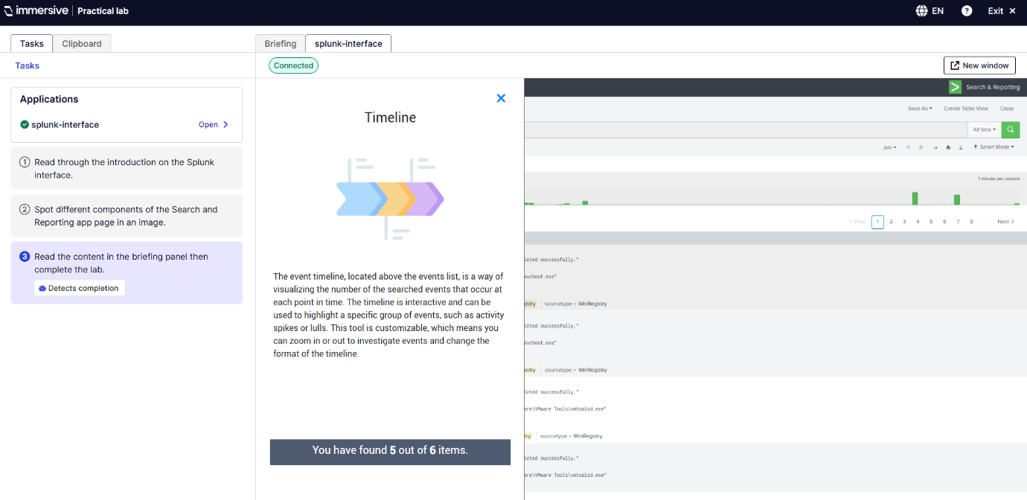
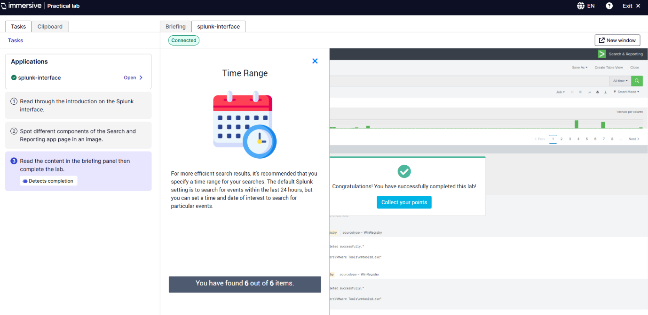
Objective: The second lab is for learning Splunk web interface and how to use the search and reporting functions.
Outcome: There were 6 items that I needed to find to complete the lab which gives me the experience using the search bar, timeline, time range, events, and viewing indexed data.
Tools used: Splunk’s GUI: Search bar, Timeline, Events, App navigation bar, Fields and Time Range.
Reflection: Helps emphasise user experience (UX) fluency allowing me the user the ability to understand the GUI and investigate alerts and results.
Splunk Basics Ep.2 Data Sources
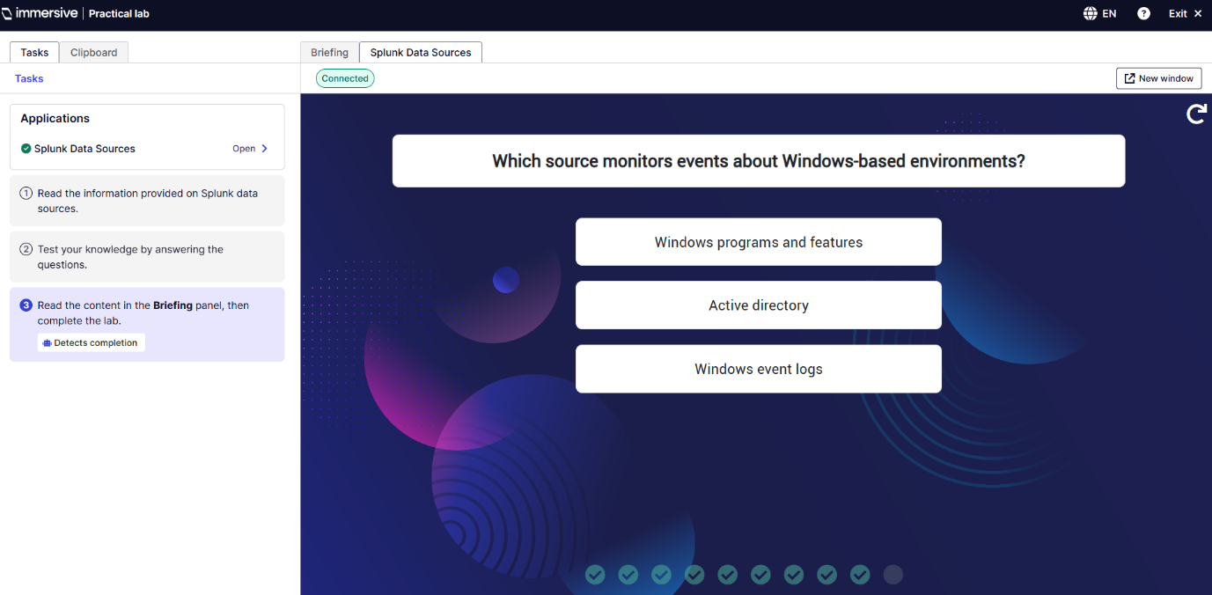
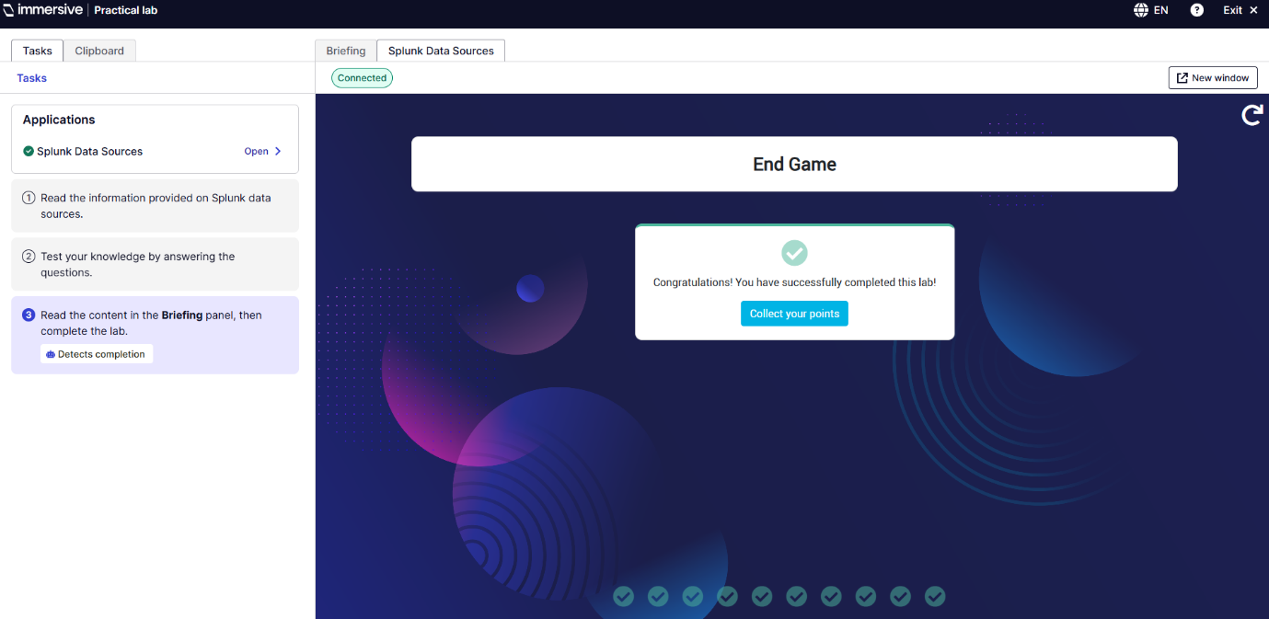
Objective: The third lab is for learning to identify and configure data sources into Splunk. This covers Network data, Script output, Windows event logs, HTTP event collector, File and directories. Also Source vs Source type “The source is the name of the file that the data has originated from, whereas the source type determines how the data will be formatted into individual events by Splunk. (Immersive Labs, 2025)”
Outcome: Got every question correct and worked with Network data, Script output, Windows event logs, HTTP event collector, File and directories. Also Source vs Source type.
Key insight: Knowing the correct data source config is needed for accurate field extraction and correlation.
Splunk Basics Ep.3 Search
Objective: The third lab is to conduct basic searches using Systems Programming Language (SPL) such as:
index=* "C:\\Users\\bob.smith.WAYNECORPINC\\AppData\\Roaming\\121214.tmp"
Outcome: Got all questions from 3 to 7 correct, this showcased the ability to interpret authentication events and filtering logs by fields or value.
Security Relevance: This is essential for identifying brute force attempts and logon anomalies.
Q3. 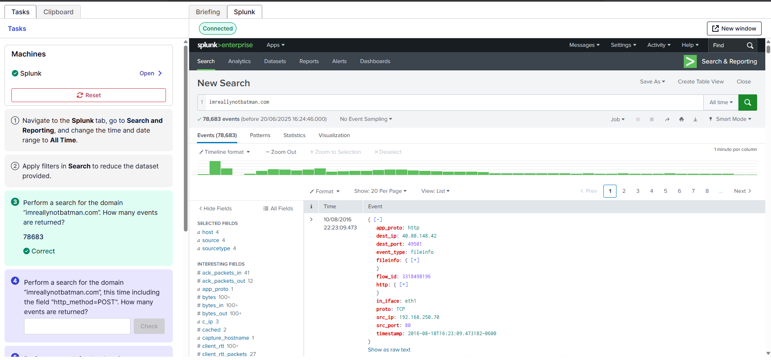
Q3. This searches for imnotreallybatman.com and for how many events are returned.
Q4. 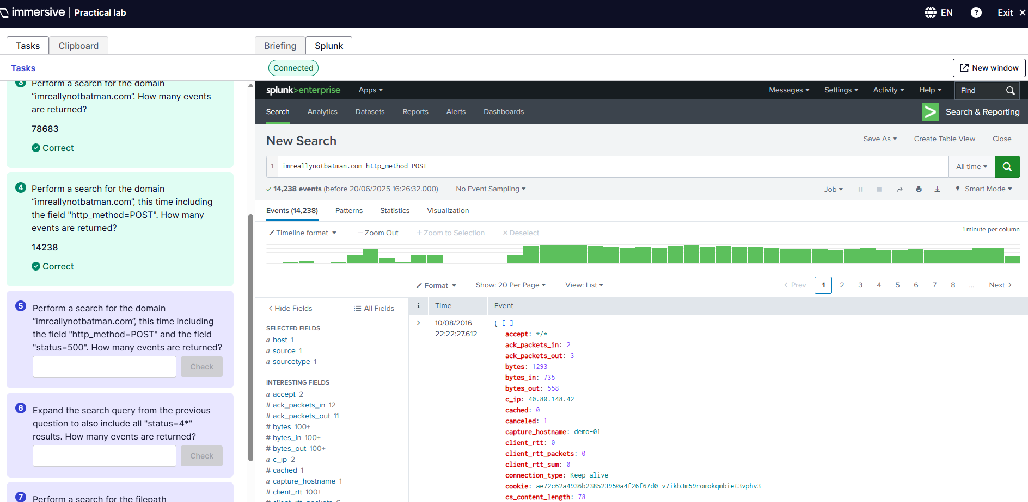
Q4. This searches for imreallynotbatman.com including the field http_method=POST and for how many events are returned.
Q5. 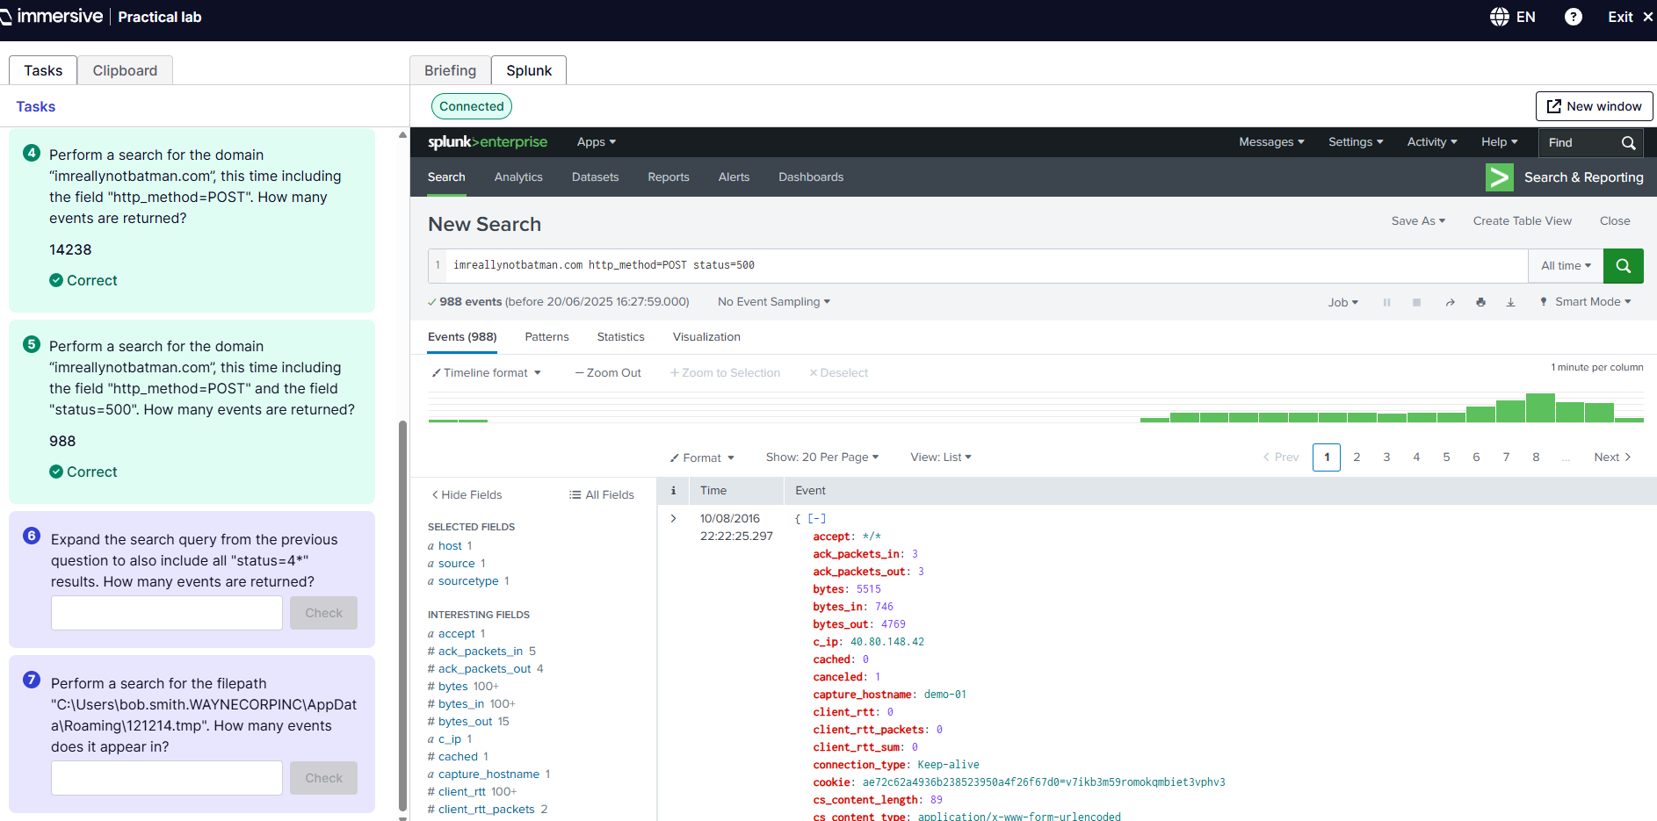
Q5. This searches for imreallynotbatman.com including the field http_method=POST and the field status=500, for how many events are returned.
Q6.
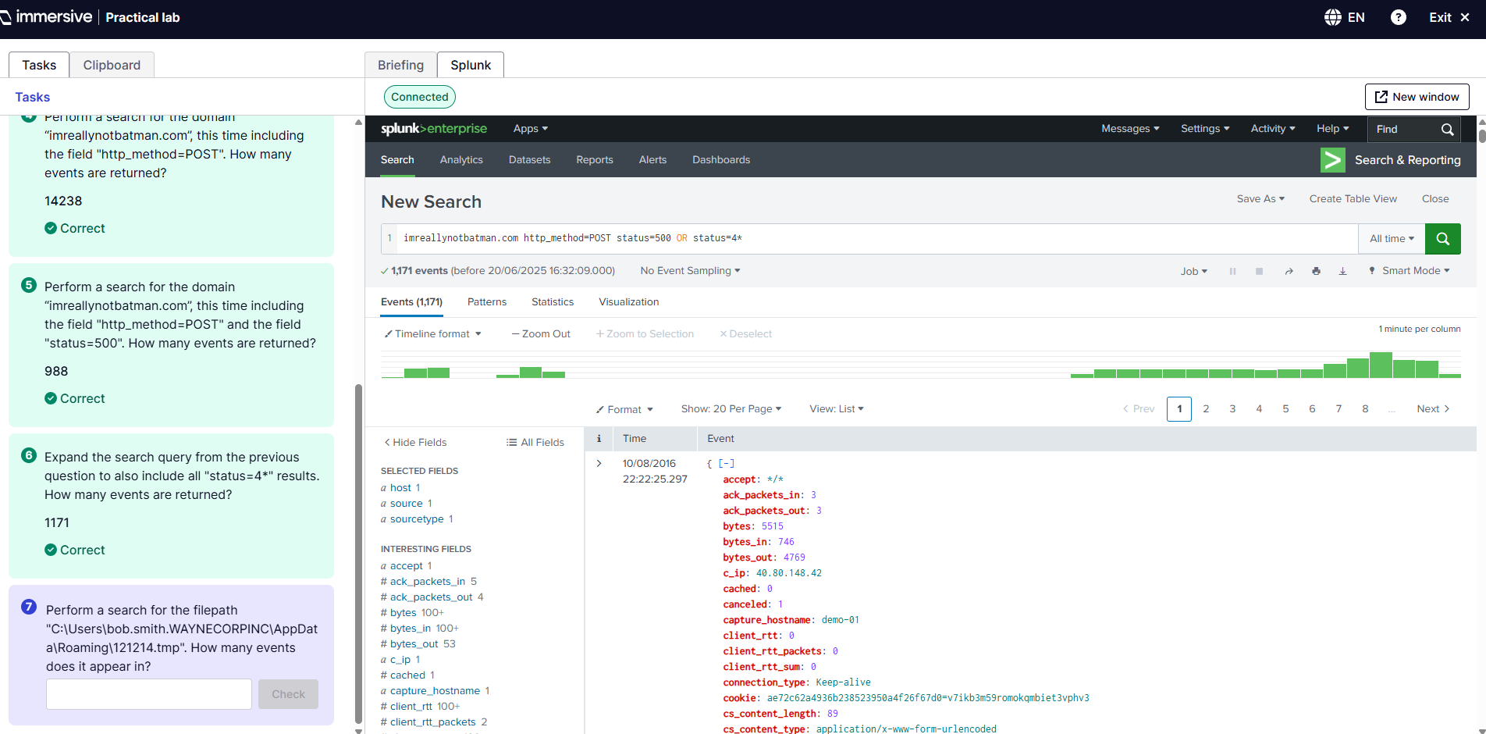
Q6. This searches for the previous query with the added field of status=4* using the OR to perform logical disjunction between multiple search terms or conditions. To show how many events are returned.
Q7.
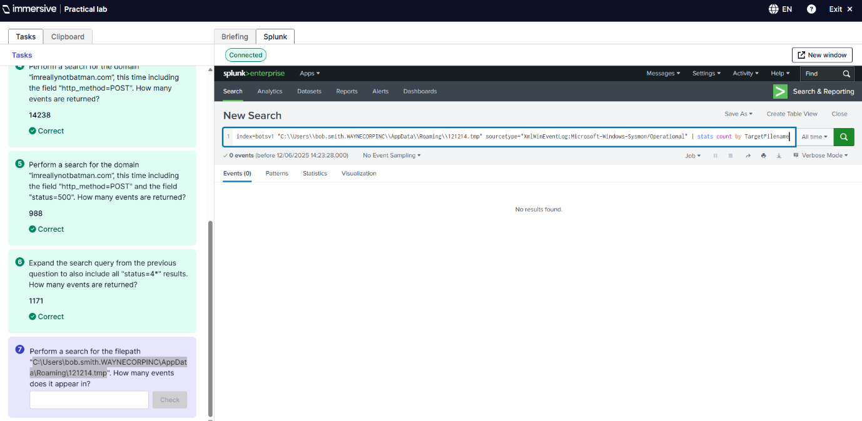
Q7. This was my first attempt at question 7 which was too long and complicated as I was trying to search by sourcetype and count by TargetFilename.
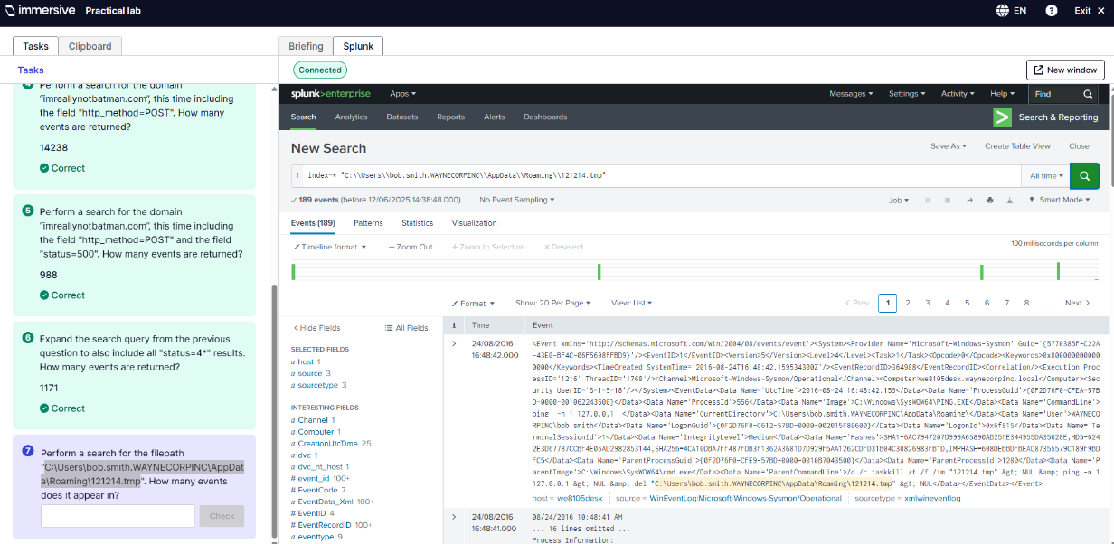
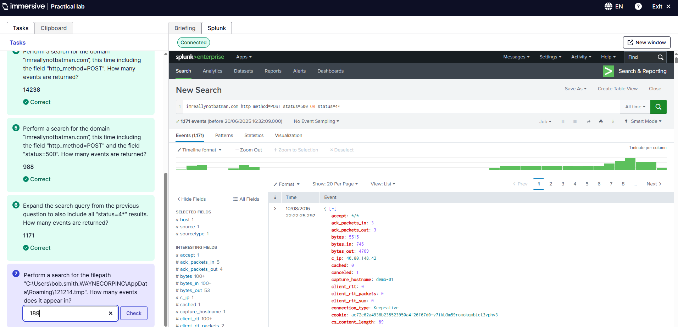
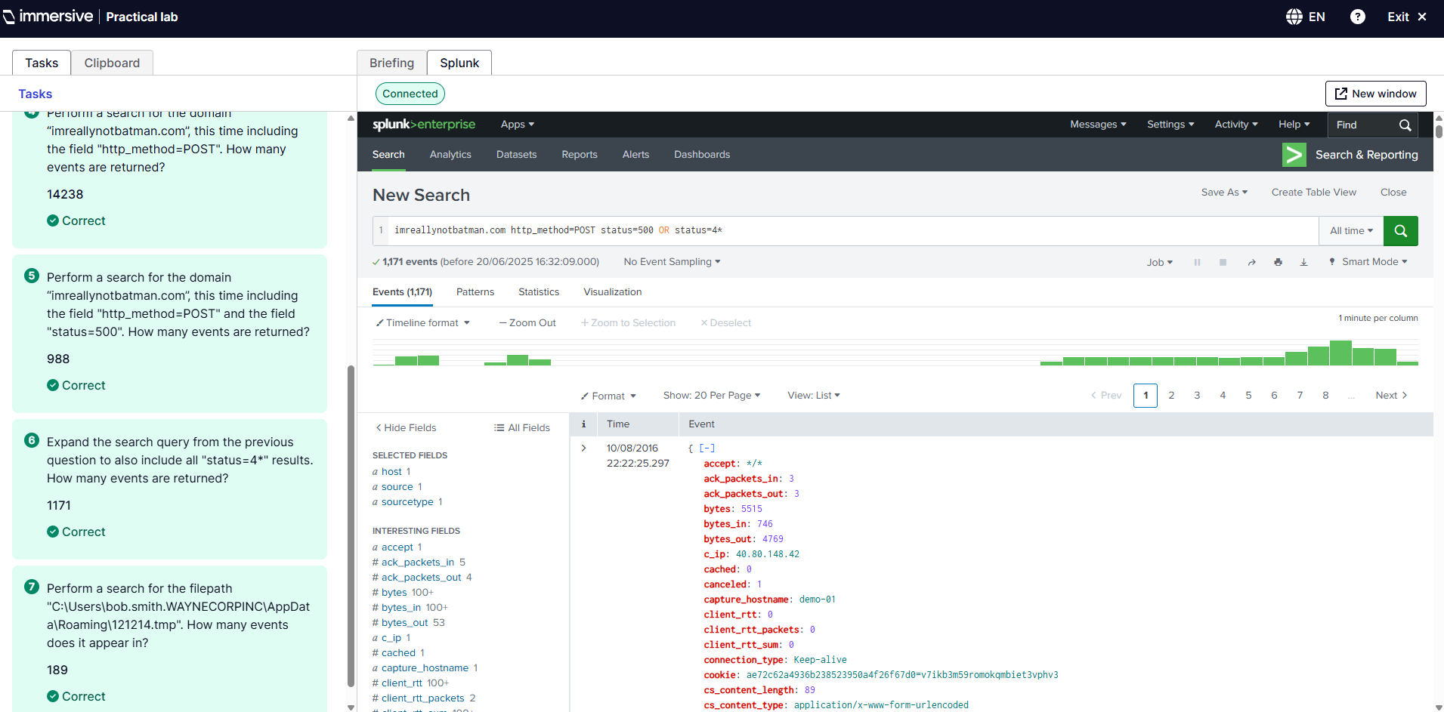
This was my second attempt in which I just removed all the extra SPL, and it worked giving me the result of 189 events which is the correct answer
Splunk Basics Ep.4 Advanced Searching
Objective: The fourth lab is using the same principles as the third lab however using leverage transforming commands like rare, stats, top, timechart and sort etc.
Techniques practiced: Rare, Stats, Count, Sort, and Top.
Outcome: Answered all questions correctly and learnt how to do advanced searches.
Q3 & 4. 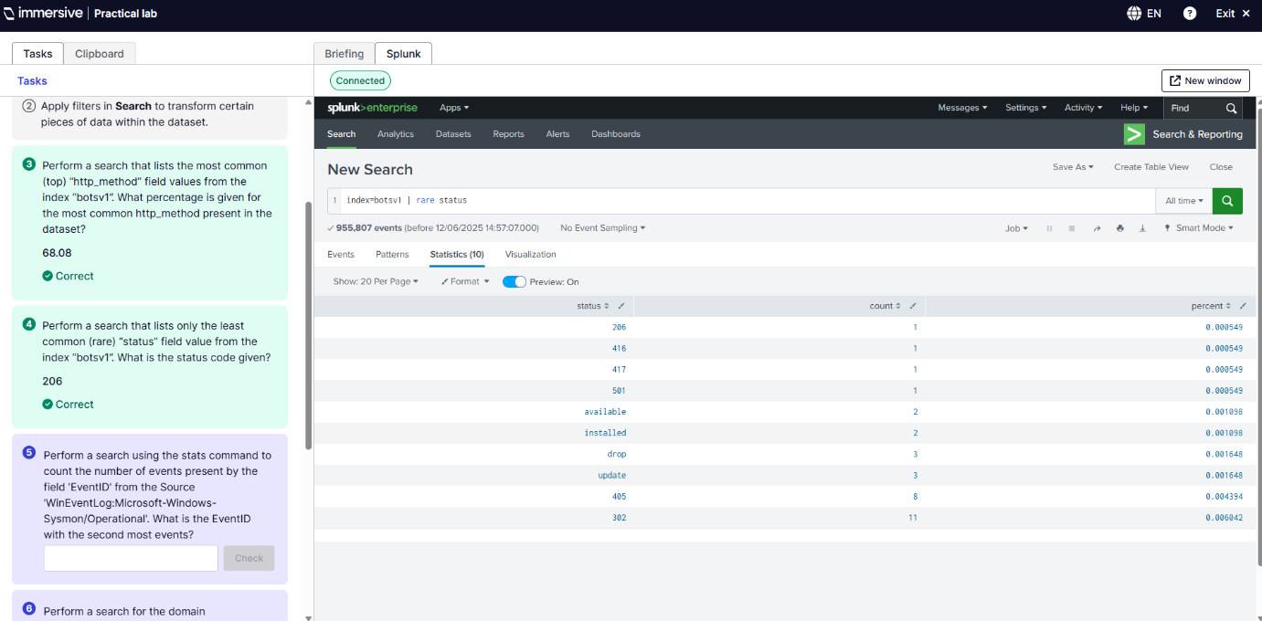
Q3. This found the most common http_method present in the field of index botsv1 using this SPL - index=botsv1 | top http_method. Returned 68.08 as the most common percentage.
Q4. This search was for the most common status field given from index-botsv1 which was 206. The SPL was index=botsv1 | rare status.

Q5. 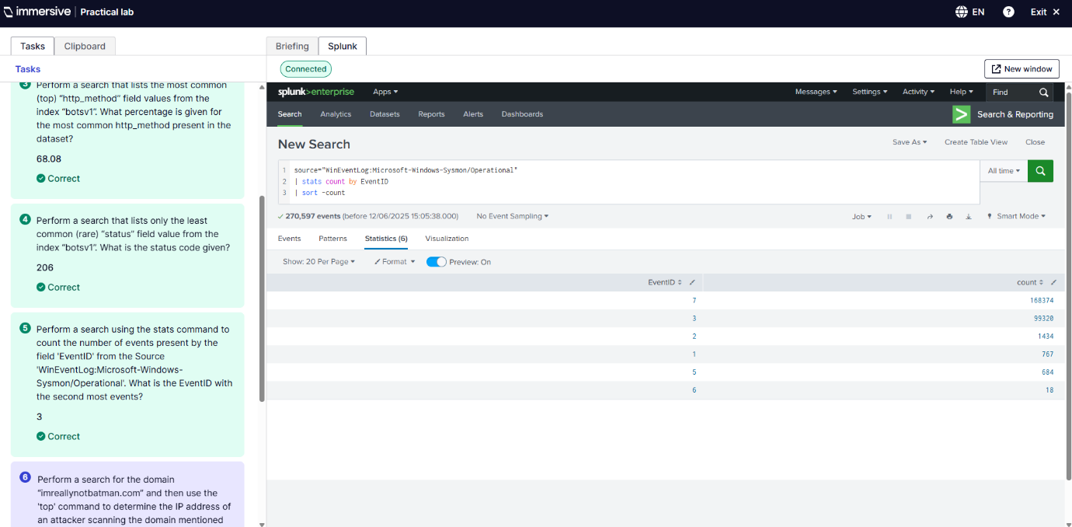
Q5. This search is for finding the EventID for the second highest count from the Source WinEventLog which was 3. The SPL for this was source=”WinEventLog:Microsoft-Windows-System/Operational” | stats count by EventID | sort -count.
Q6. 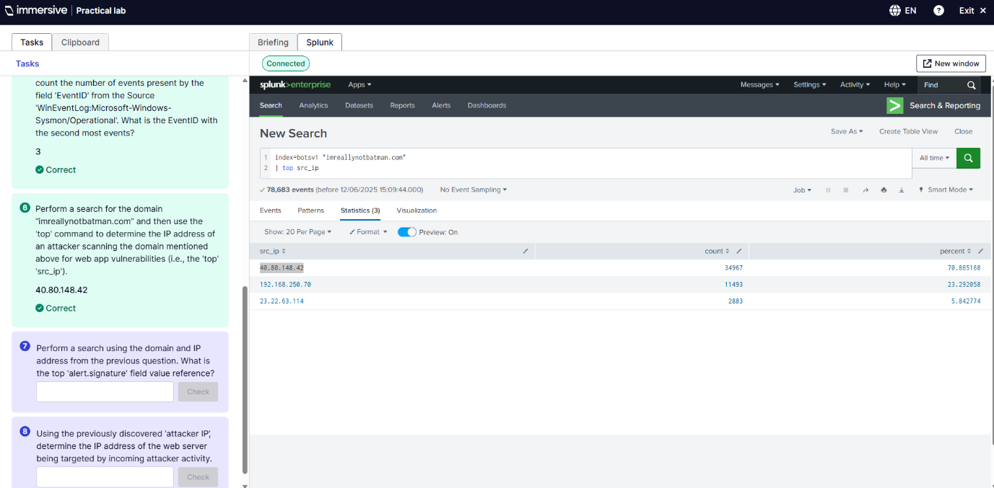
Q6. This was to search the domain imreallynotbatman.com in the field of index=botsv1 to find the top IP address. Which was 40.80.148.42. The SPL for this was index=botsv1 “imnotreallybatman.com | top src_ip.

Q7. 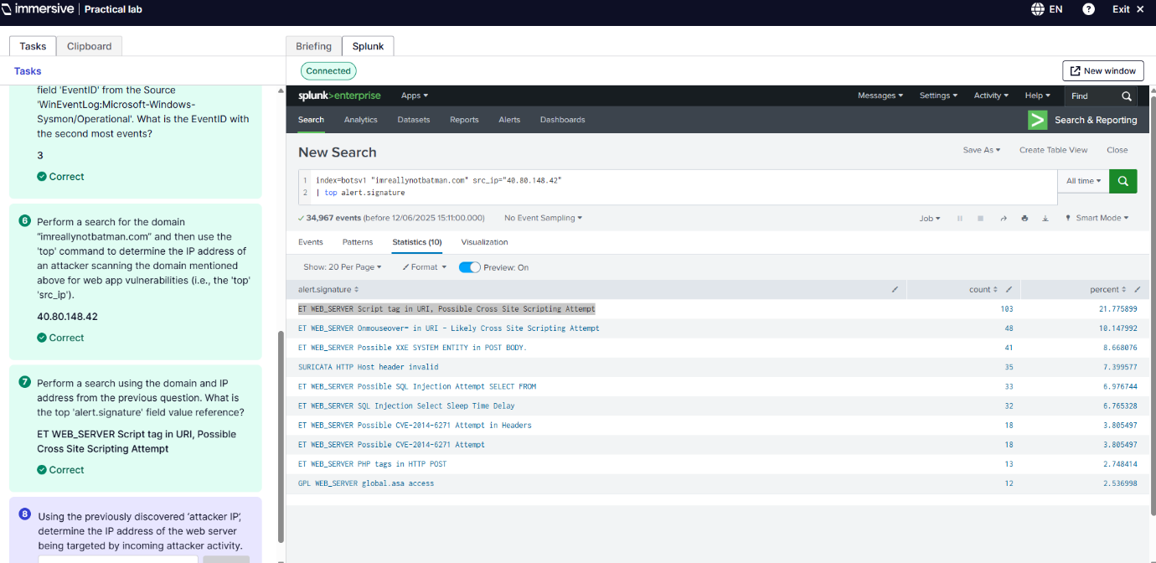
Q7. This was to search for the top alert signature using the previous questions IP address. The SPL for this is: index=botsv1 “imreallynotbatman” src_ip”40.80.148.42” | top alert.signature.
Q8. 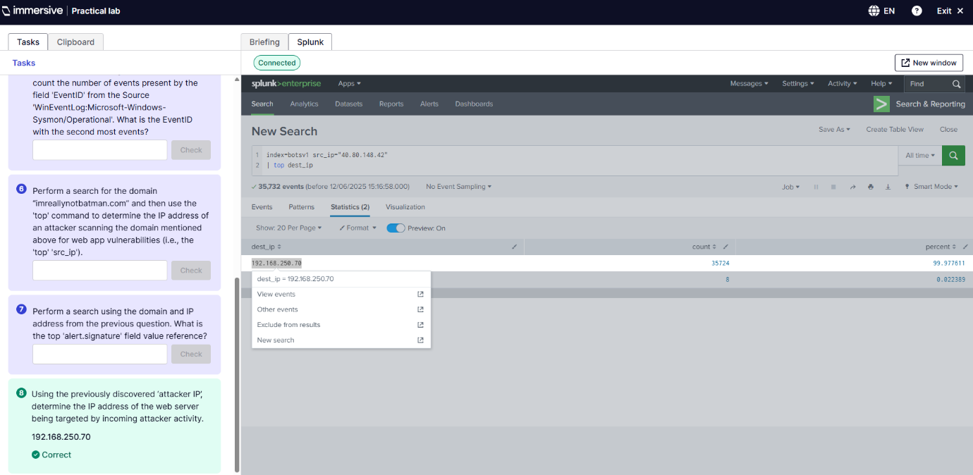
Q8. This is a search using the previous attacker IP to determine the IP address of the web server being targeted which is 192.168.250.70. The SPL: index=botsv1 src=ip=”40.80.148.42” | top dest_ip.
Splunk Basics Ep.5 Dashboards
Q6.
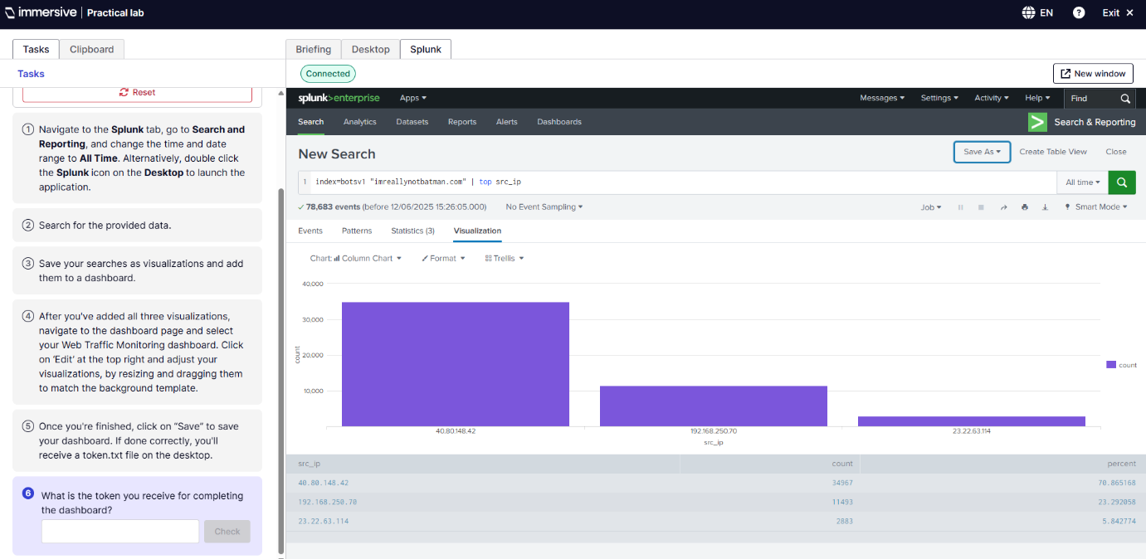
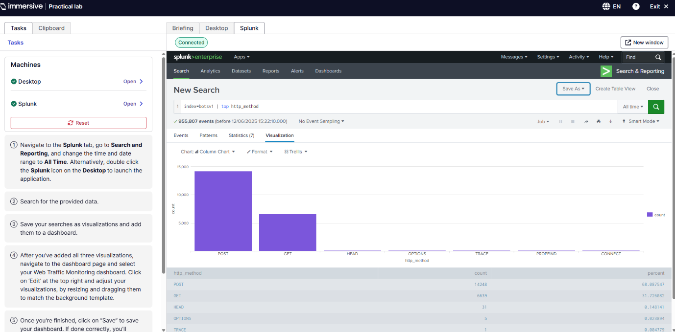
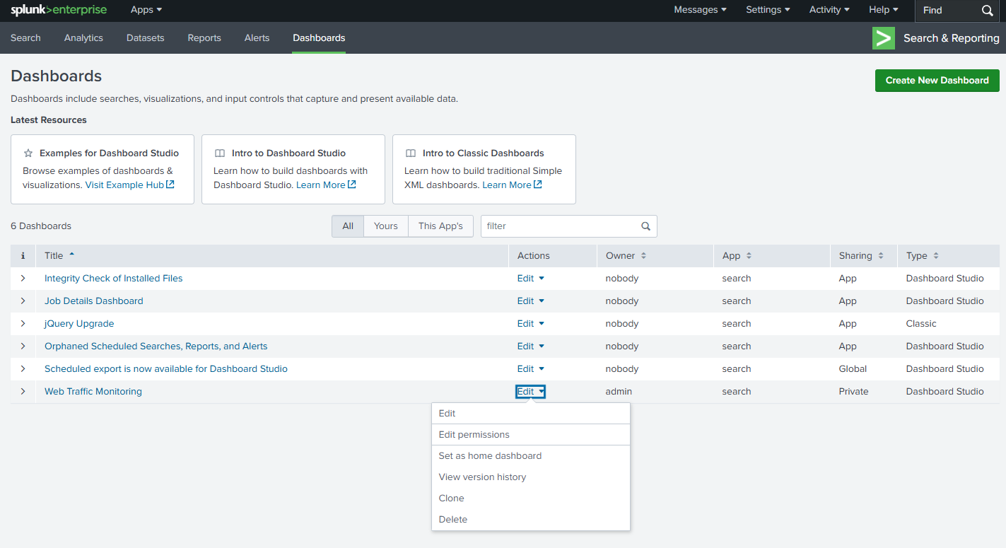
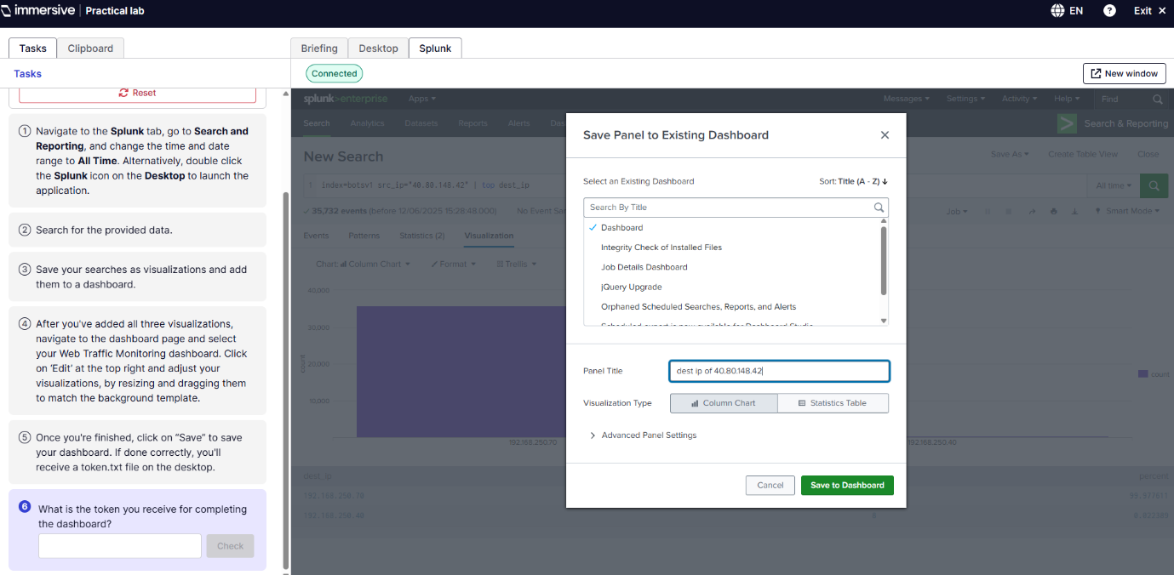
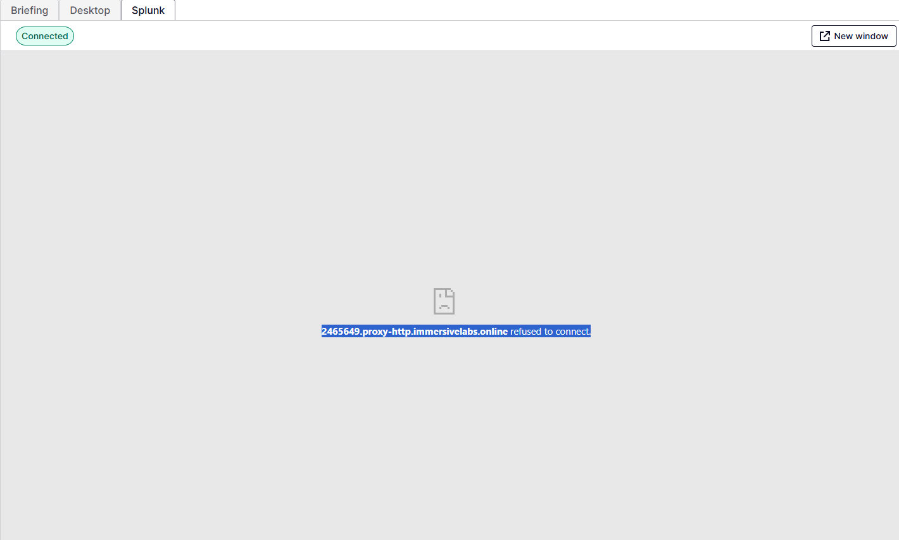

Objective: To create dashboards using saved searches and visual elements
Skills demonstrated: Configuring bar charts, line graphs and conditional formatting. Also to create reusable panels for SOC reporting.
Use case: Create visualisations of threat actor activities, brute force attack trends and host anomalies.
Outcome: I managed to create all three dashboards and save them however it would not save due to a proxy issue inside the immersive labs VM and would not give me the token. So was unsuccessful.
Splunk Basics: Demonstrate your skills
Objective: This final lab centred on simulating the work of a new junior Security Operations Centre (SOC) analyst beginning their real work. With a few weeks' training under their belt, the analyst should now have the capability to review and analyse security logs by themselves. The primary goals were to explore available dashboards, familiarize oneself with available sources of logs, look for and study HTTP traffic, and run detailed searches on hosts that have been displaying suspicious behaviour (ImmersiveLabs, 2025).
Scenario summary:
As a new SOC analyst, you can access your company's Splunk environment. Your assignment is to learn about different sources of security logs and develop the skills required to investigate for possible threats. In this exercise, you are working with a simulated enterprise scenario using log data from Splunk's Boss of the SOC (BOTS) Capture the Flag (CTF) dataset (ImmersiveLabs, 2025).
I have been tasked to complete these:
- Enumerate log sources to find your telemetry coverage
- Browsing dashboards to derive situational awareness
- Analysing HTTP traffic patterns
- Searching for suspicious activity compared to specific endpoints or users
- Using SPL to identify signs of compromise (ImmersiveLabs, 2025)
Outcome:
Analysis comprised a series of SPL-based exercises:
- Log Source Enumeration: Identified active log sources in the botsv1 index via metadata searches.
- HTTP Traffic Inspection: Scoped HTTP requests with sourcetype=stream:http and identified suspicious domains and URIs.
- Host-Based Investigation: Queried across Sysmon and Windows Event Logs to track suspicious process execution on infected hosts.
- Registry Persistence Check: Searched registry-based logs for unauthorized changes that might constitute persistence mechanisms.
- IDS Alert Review: Reviewed Suricata logs for malware signatures, which helped to corroborate host-level findings with network-based alerts (ImmersiveLabs, 2025).
During the exercise, I have successfully:
- Navigated multiple security data sources in Splunk.
- Applied correlation techniques between host and network logs.
- Developed basic threat-hunting and triage capabilities with SPL.
- Identified suspicious activity at multiple layers: host (process execution), network (HTTP activity), and perimeter (firewall logs) (ImmersiveLabs, 2025).

Q5. 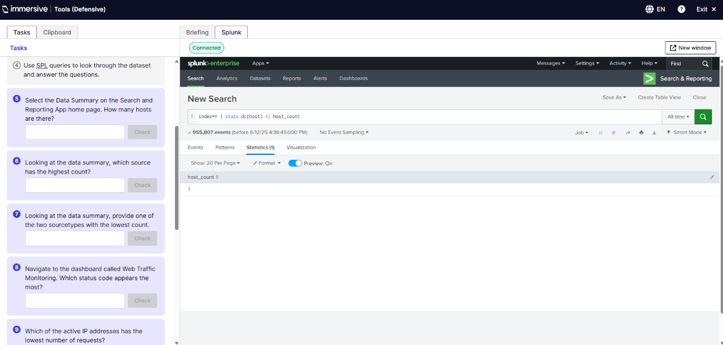
Q5. This was to select the Data Summary and showcase how many hosts there are, which was 7. The SPL for this is: index=* | stats dc(host) AS host_count.
Q6. 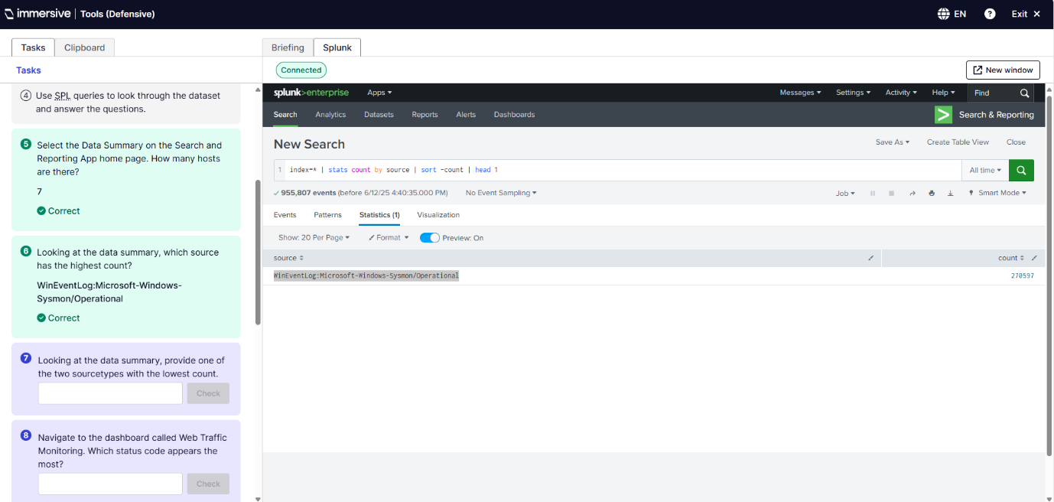
Q6. This is to find the source with the highest count which was WinEventLog. The SPL used: index=* | stats count by source | sort -count | head 1.
Q7. 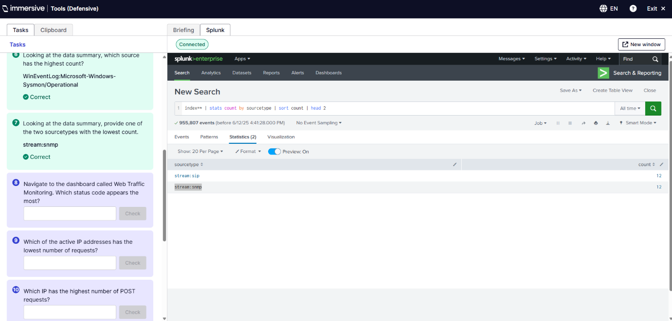
Q7. This was to find a source type with the lowest count both had the count of 12 so I tried both and the stream:snmp was the correct one. The SPL used: index=* | stats count by sourcetype | sort count | head 2.
Q8. 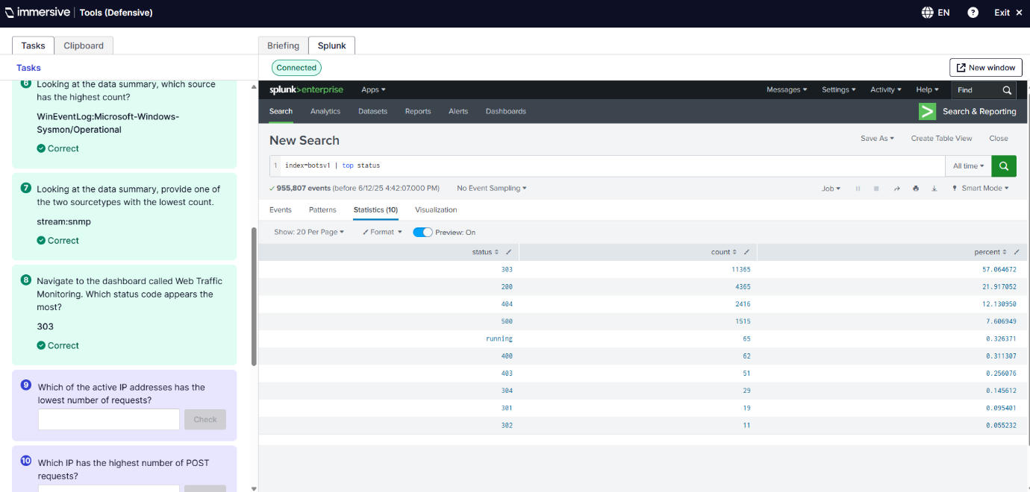
Q8. This one is to find the status code that appears the most, I did this via SPL instead of using the Web Traffic Monitoring dashboard giving me the status of 303 with the count of 11365. SPL used: index=botsv1 | top status.
Q9.
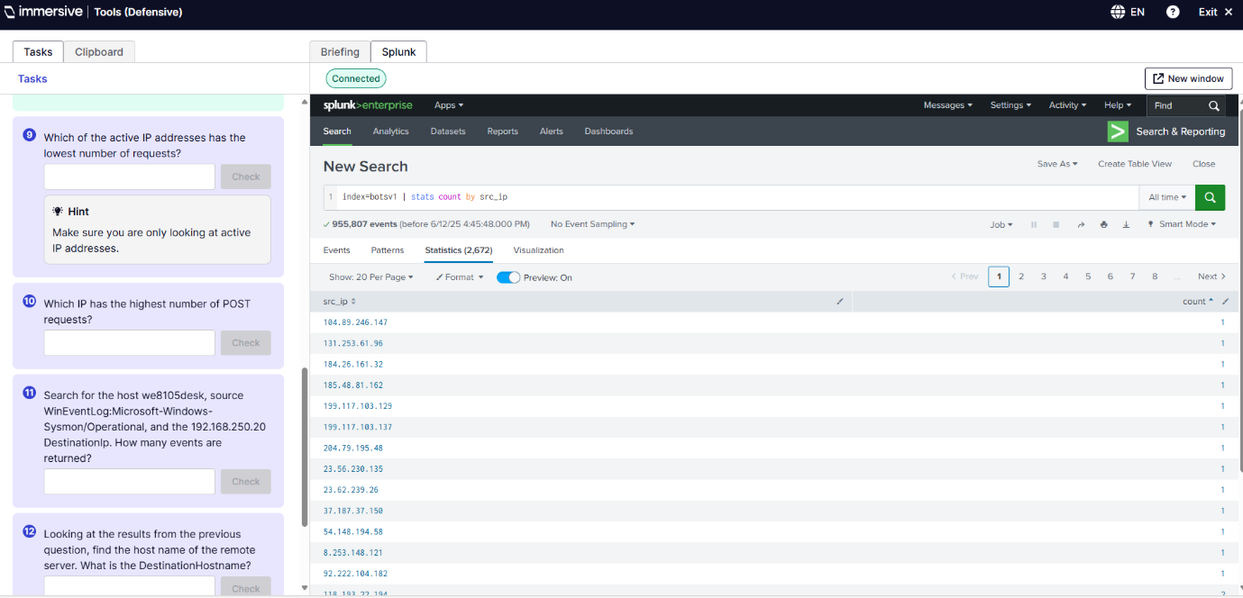
Q9. This was my first attempt at finding the active IP address that has the lowest number of requests there was 2,672 events to sort through. The SPL used: index=botsv1 | stats count by src_ip. This was too many events to trail and error the answer so I tweaked the SPL below
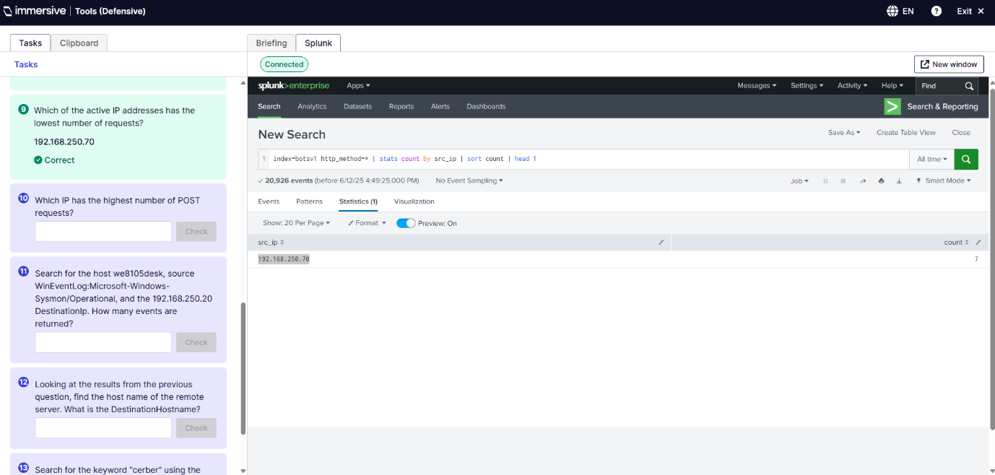
Q9. This is how I got the correct answer as it said active IP I added http_method-* so it only shows active IP addresses, then sorted by count. The SPL used: index=botsv1 http_method-* | stats count by src_ip | sort count | head 1.
Q10. 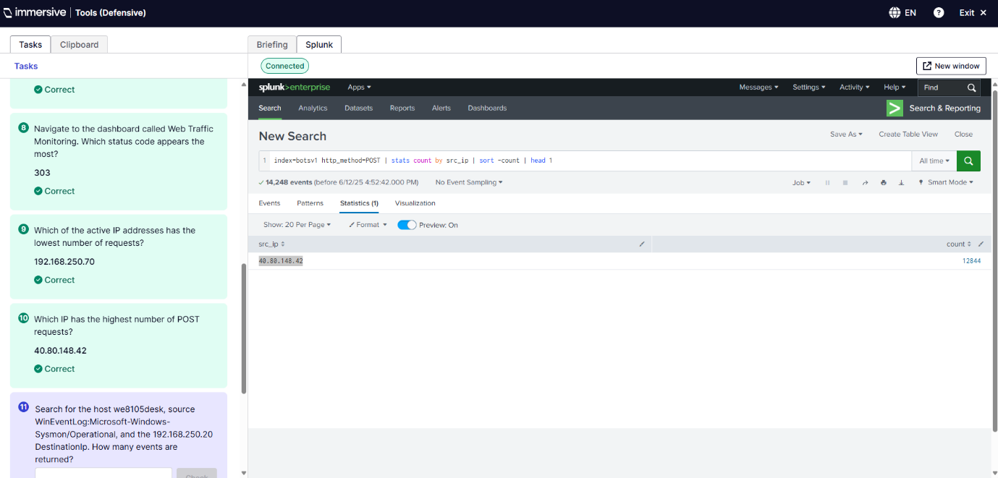
Q10. This was to find the IP with the highest POST requests, so I used the same SPL as last time just changed the * for all to POST to filter the requests and -count to find the highest number of requests. SPL used: index=botsv1 http_method-POST | stats count by src_ip | sort -count | head 1.
Q11. 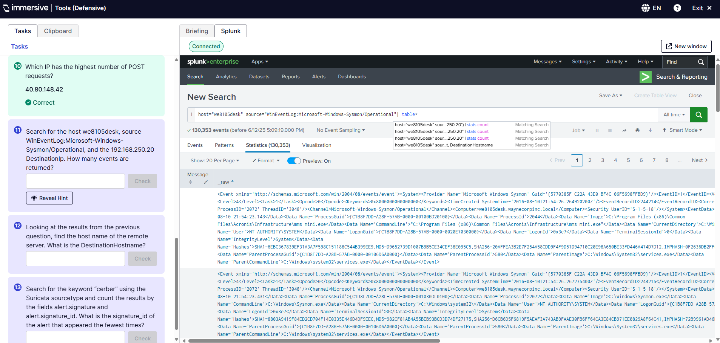
Q11. This was my first query attempt to see how many results are given when all tables are shown. Shows 130,353 events so need to filter the results more. SPL used: host=”we8105desk” source=”WinEventLog:Microsoft-Windows-Sysmon/Operational” | table*.
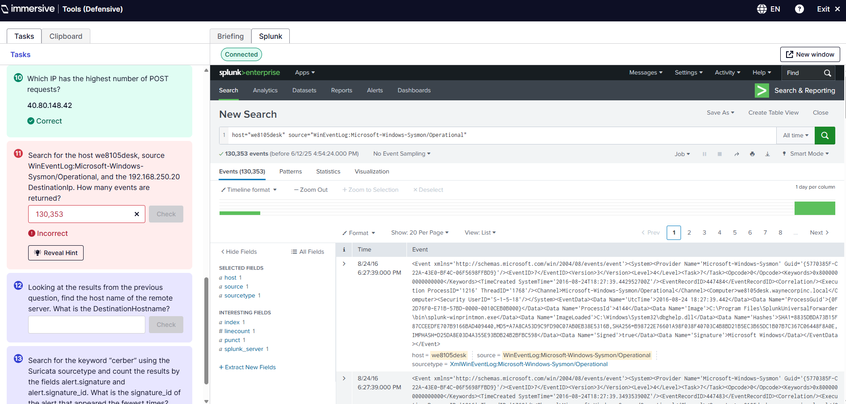
Q11. This was me checking if it was correct and it wasn’t.
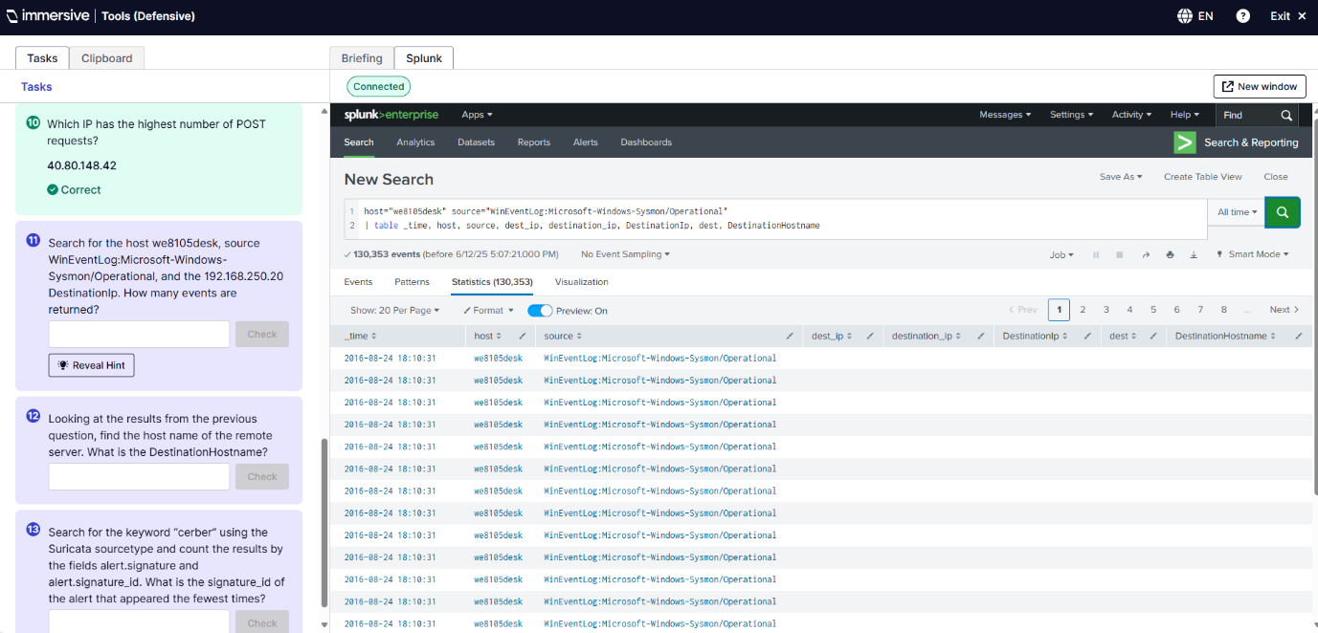
Q11. This was an attempt to see if it had table header names for destination_ip and it did not so try a different query.
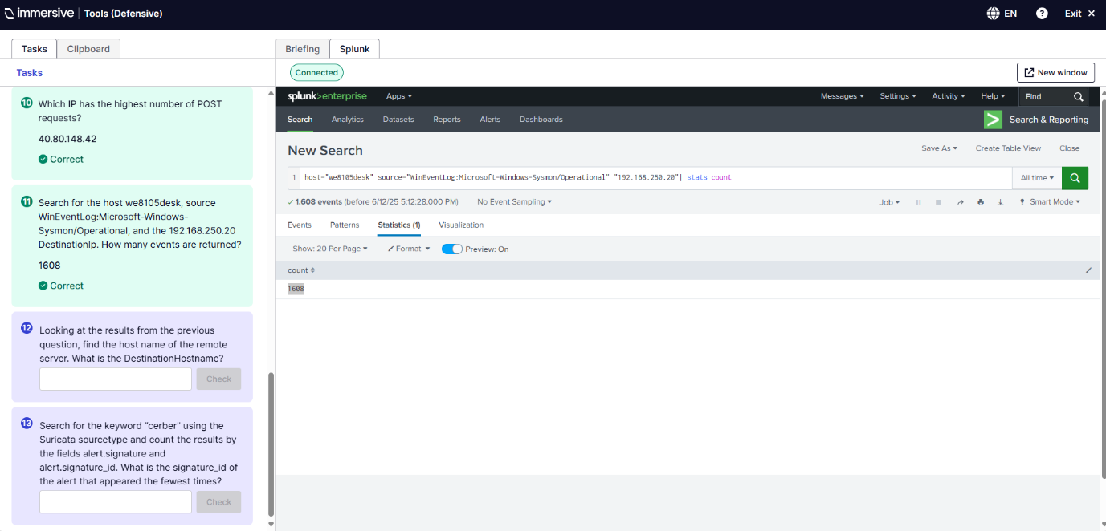
Q11. This one worked where I added the IP address to the query and used count. The SPL used: host=”we8105desk” source=”WinEventLog:Microsoft-Windows-Sysmon/Operational” “192.168.250.20” | stats count.
Q12. 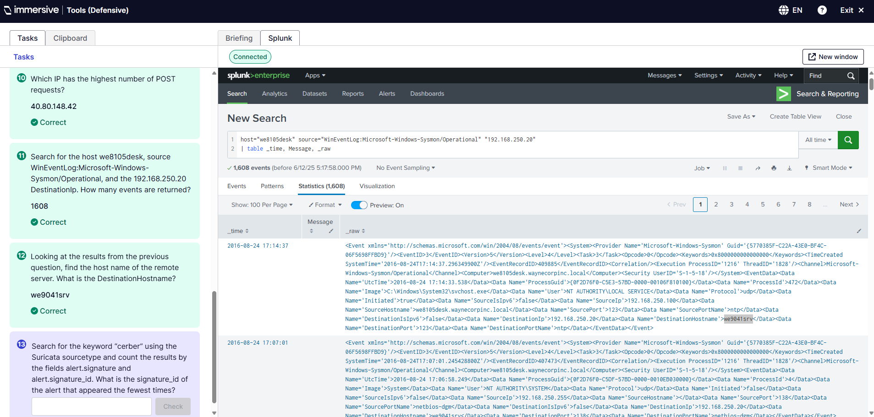
Q12. This was to find the host name of the remote server to find the DestinationHostname from the previous query. I changed it to show three tables, _time, Message, and _raw and looked through the raw data where the Data Name DestinationHostname was found giving me the answer of we9041srv. SPL used: host=”we8105desk” source=”WinEventLog:Microsoft-Windows-Sysmon/Operational” “192.168.250.20” | table _time, Message, _raw.
Q13. 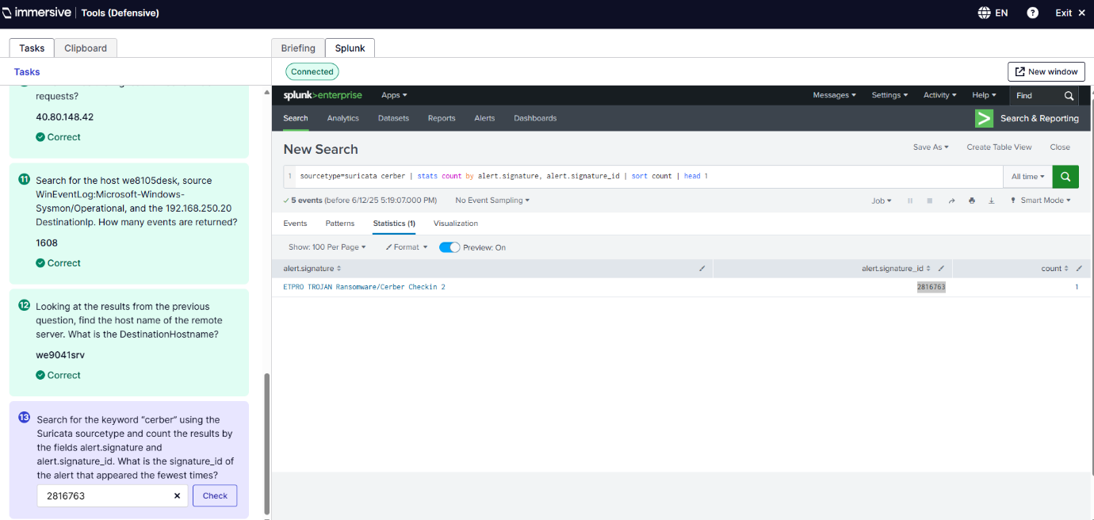
Q13. This query was to search for the keyword cerber using the Suricata sourcetype and count the results by the alert.signature and id to find the alert that was found the fewest times. The SPL used: sourcetype=suricata cerber | stats count by alert.signature, alert.signature_id | sort count | head 1.

Conclusion
The cyber threat landscape for Pingu Services Ltd. is multifaceted and rapidly evolving given the organization has just been acquired by Capital Science Group. Pingu Services Ltd. has previously handled sensitive data, a history of ISO 27001 certification, and developed both hardware and software; Pingu Services Ltd. is subject to a range of sector-specific and more general cyber risks. These cyber risks include but are not limited to, ransomware, insider threats, insecure legacy systems, email filtering and phishing, and each risk offers unique opportunities for targeted and evidence-based mitigation strategies.
The cyber threat landscape analysis has uncovered large risk exposures in several areas of endpoint security, data segregation, email filtering, and access control. The ransomware event Pingu experienced through an attacker using a phishing PDF disguised as a CV shows how easy it is for threat actors to exploit human failures. Despite this, Pingu’s ability to restore following a backup operation after three days, is a minor level of resilience that should be fully supported by a routine disaster recovery plan, automated failover, and by maintaining an immutable backup (Adnan et al., 2023).
Our vulnerability assessment highlighted critical vulnerabilities in system architecture and organizational practices. Legacy systems like Windows Server 2016 and flat user access structures present exploitable vectors during a time when roles are being transitioned, and personnel reductions are expected. Thus, a finer-grained access control model that falls within Zero Trust principles, such as role-based access control (RBAC) and least privilege access, should be established.
Defence in depth will serve as the foundation of Pingu's overall cybersecurity posture. This includes deploying perimeter defences (i.e., WatchGuard Firebox M390), network segmentation, encrypting data in transit and at rest, deploying EDR tools, and behavioural analytics for anomaly detection. Written policies should reflect the use of the various controls, and continual user awareness training should strengthen humans’ cyber knowledge (Maleh, Sahid and Belaissaoui, 2021).
One of the most efficient aspects of this multi-layered defence is extensive log analysis. As evidenced by the applied lab work using Splunk, this reflects the value of monitoring logs live for alerting on advance threat detection. By ingesting, searching, and visualizing data from multiple endpoints and network devices, Splunk permits SOC analysts to quickly identify indicators of compromise (IOCs). Splunk's Search Processing Language (SPL) permits advanced searching on individual event types as failed logins, unusual file access, and privilege escalation (Farooq and Otaibi, 2018).
Using dashboards and visual analysis facilitates situational awareness making it easier to comprehend large amounts of security data in a timely manner. Automating searches and alerts ensures that serious events are not missed, while supporting requirements from both ISO 27001 and NIST CSF. Collectively, Splunk means monitoring incidents only helps reduce mean time to detection (MTTD), it allows improved incident response and reporting (Bumblauskas et al., 2017).
Splunk being part of a larger Security information and event management (SIEM) picture could be considered a long-term investment strategy for CSG and Pingu. Adding in Splunk or another SIEM will address compliance, audit readiness, and continuous monitoring. As CSG could be entering a stage of consolidation of IT case, post-acquisition, having Splunk or a similar SIEM will be critical for success (Ban et al., 2021).
To summarize, this report demonstrates that a layered, dynamic, responsive cybersecurity strategy is necessary based on both best practices and empirical tools. Addressing the technical elements as well as the human factors, and potential for real time monitoring and identification, Pingu Services can sleep easy and confidently transition to the next stage of their operation (Nobles, 2018). This also highlights the experience gained through the labs as a gentle reminder to marry technical competencies with strategic vision Pingu not just has to be compliant but also must prepare for the modern life cycle of cyber resilience.

References
Abbott, J. and Patil, S., 2020. How Mandatory Second Factor Affects the Authentication User Experience [Online]. Proceedings of the 2020 CHI Conference on Human Factors in Computing Systems. Available from: https://doi.org/10.1145/3313831.3376457 [Accessed 20 June 2025].
Acharya, H.B., Joshi, A. and Gouda, M.G., 2010. Firewall modules and modular firewalls [Online]. CiteSeer X (The Pennsylvania State University), pp.174–182. Available from: https://doi.org/10.1109/icnp.2010.5762766 [Accessed 28 May 2025].
Adnan, M., Muhammad, Javed, M. and Iqbal Murtza, 2023. Improving spam email classification accuracy using ensemble techniques: a stacking approach [Online]. International Journal of Information Security. Available from: https://doi.org/10.1007/s10207-023-00756-1 [Accessed 27 June 2025].
Alaranta, M. and Henningsson, S., 2008. An approach to analyzing and planning post-merger IS integration: Insights from two field studies [Online]. Information Systems Frontiers, 10(3), pp.307–319. Available from: https://doi.org/10.1007/s10796-008-9079-2 [Accessed 26 June 2025].
Almomani, A., Gupta, B.B., Atawneh, S., Meulenberg, A. and Almomani, E., 2013. A Survey of Phishing Email Filtering Techniques [Online]. IEEE Communications Surveys & Tutorials, 15(4), pp.2070–2090. Available from: https://doi.org/10.1109/surv.2013.030713.00020 [Accessed 20 June 2025].
Alsowail, R.A. and Al-Shehari, T., 2021. A Multi-Tiered Framework for Insider Threat Prevention [Online]. Electronics, 10(9), p.1005. Available from: https://doi.org/10.3390/electronics10091005 [Accessed 26 June 2025].
Ampel, B.M., Samtani, S., Zhu, H., Chen, H. and Nunamaker, J.F., 2024. Improving Threat Mitigation Through a Cybersecurity Risk Management Framework: A Computational Design Science Approach [Online]. Journal of Management Information Systems, 41(1), pp.236–265. Available from: https://doi.org/10.1080/07421222.2023.2301178 [Accessed 24 June 2025].
Anwita, 2023. What is ISO 27001 Compliance? [101 Guide to Certification] [Online]. Sprinto. Available from: https://sprinto.com/blog/iso-27001-compliance/ [Accessed 27 May 2025].
Ban, T., Samuel, N., Takahashi, T. and Inoue, D., 2021. Combat Security Alert Fatigue with AI-Assisted Techniques [Online]. Cyber Security Experimentation and Test Workshop. Available from: https://doi.org/10.1145/3474718.3474723 [Accessed 28 June 2025].
Bauer, R., 2019. Ransomware: How to Prevent Being Attacked and Recover After an Attack [Online]. Backblaze Blog | Cloud Storage & Cloud Backup. Available from: https://www.backblaze.com/blog/complete-guide-ransomware/ [Accessed 27 May 2025].
Bumblauskas, D., Nold, H., Bumblauskas, P. and Igou, A., 2017. Big data analytics: transforming data to action [Online]. Business Process Management Journal, 23(3), pp.703–720. Emerald. Available from: https://doi.org/10.1108/bpmj-03-2016-0056 [Accessed 28 June 2025].
Chandrasekaran, M., Chinchani, R. and Upadhyaya, S., 2006. PHONEY: mimicking user response to detect phishing attacks [Online]. IEEE Xplore. pp.5 pp.–672. Available from: https://doi.org/10.1109/WOWMOM.2006.87 [Accessed 22 June 2022].
CISA, 2016. Recommended Practice: Improving Industrial Control System Cybersecurity with Defense-in-Depth Strategies Industrial Control Systems Cyber Emergency Response Team [Online]. Available from: https://www.cisa.gov/sites/default/files/recommended_practices/NCCIC_ICS-CERT_Defense_in_Depth_2016_S508C.pdf [Accessed 30 May 2025].
Cyberhaven, 2024. Top IP theft statistics and stories in 2023 | Cyberhaven [Online]. www.cyberhaven.com. Available from: https://www.cyberhaven.com/guides/top-ip-theft-statistics [Accessed 27 May 2025].
Farooq, H.M. and Otaibi, N.M., 2018. Optimal Machine Learning Algorithms for Cyber Threat Detection [Online]. IEEE Xplore. pp.32–37. Available from: https://doi.org/10.1109/UKSim.2018.00018 [Accessed 28 June 2025].
Gallegos-Segovia, P.L., Bravo-Torres, J.F., Larios-Rosillo, V.M., Vintimilla-Tapia, P.E., Yuquilima-Albarado, I.F. and Jara-Saltos, J.D., 2017. Social engineering as an attack vector for ransomware [Online]. IEEE Xplore. pp.1–6. Available from: https://doi.org/10.1109/CHILECON.2017.8229528 [Accessed 26 June 2025].
GOV.UK, 2016. Cyber security training for business [Online]. GOV.UK. Available from: https://www.gov.uk/government/collections/cyber-security-training-for-business [Accessed 30 May 2025].
Hafizhan Irawan, Alva Hendi Muhammad and Nasiri, A., 2024. Design of Cybersecurity Maturity Assessment Framework Using NIST CSF v1.1 and CIS Controls v8 [Online]. Jurnal Inovtek Polbeng Seri Informatika, 9(1). Available from: https://doi.org/10.35314/isi.v9i1.3973 [Accessed 28 May 2025].
IBM, 2021. Insider threats [Online]. Ibm.com. Available from: https://www.ibm.com/think/topics/insider-threats [Accessed 27 May 2025].
ICO, 2023. Data protection officers [Online]. ico.org.uk. Available from: https://ico.org.uk/for-organisations/law-enforcement/guide-to-le-processing/accountability-and-governance/data-protection-officers/ [Accessed 30 May 2025].
Immersive Labs, 2025. Immersive [Online]. Immersivelabs.online. Available from: https://immersivelabs.online/v2/labs/splunk-basics-ep-2-data-sources/series/splunk [Accessed 24 June 2025].
ImmersiveLabs, 2025. Immersive [Online]. Immersivelabs.online. Available from: https://immersivelabs.online/v2/labs/splunk-basics-ep6-demonstrate-splunk [Accessed 25 June 2025].
Kadry, S. and Joumaa, C., 2025. Green WSUS [Online]. arXiv.org. Available from: https://arxiv.org/abs/1212.6046 [Accessed 28 May 2025].
Kafi, M. and Akter, N., 2023. Securing Financial Information in the Digital Realm: Case Studies in Cybersecurity for Accounting Data Protection [Online]. American journal of trade and policy, 10(1), pp.15–26. Available from: https://doi.org/10.18034/ajtp.v10i1.659 [Accessed 21 June 2025].
Karim, N.A., Kanaker, H., Abdulraheem, W.K., Ghaith, M.A., Alhroob, E. and Alali, A.M.F., 2024. Choosing the right MFA method for online systems: A comparative analysis [Online]. International Journal of Data and Network Science, 8(1), pp.201–212. Available from: https://doi.org/10.5267/j.ijdns.2023.10.003 [Accessed 28 May 2025].
Koca, M., 2024. Real-Time Security Risk Assessment From CCTV Using Hand Gesture Recognition [Online]. IEEE Access, 12, pp.84548–84555. Available from: https://doi.org/10.1109/access.2024.3412930 [Accessed 30 May 2025].
Korolov, M., 2021. Supply chain attacks show why you should be wary of third-party providers [Online]. CSO Online. Available from: https://www.csoonline.com/article/561323/supply-chain-attacks-show-why-you-should-be-wary-of-third-party-providers.html [Accessed 27 May 2025].
Laliberte, M., 2024. WatchGuard Firebox SSO Client and Agent Vulnerabilities | WatchGuard Technologies [Online]. Watchguard.com. Available from: https://www.watchguard.com/wgrd-blog/watchguard-firebox-sso-client-and-agent-vulnerabilities [Accessed 28 May 2025].
Lenaerts-Bergmans, B., 2023. What is Spear Phishing? Definition with Examples | CrowdStrike [Online]. Crowdstrike.com. Available from: https://www.crowdstrike.com/en-us/cybersecurity-101/social-engineering/spear-phishing/ [Accessed 27 May 2025].
Malatji, M., 2023. Management of enterprise cyber security: A review of ISO/IEC 27001:2022 [Online]. IEEE Xplore. pp.117–122. Available from: https://doi.org/10.1109/CyMaEn57228.2023.10051114 [Accessed 20 June 2025].
Maleh, Y., Sahid, A. and Belaissaoui, M., 2021. A MATURITY FRAMEWORK FOR CYBERSECURITY GOVERNANCE IN ORGANIZATIONS [Online]. EDPACS, 63(6), pp.1–22. Available from: https://doi.org/10.1080/07366981.2020.1815354 [Accessed 28 June 2025].
Muharrom, M. and Saktiansyah, A., 2023. Analysis of Vulnerability Assessment Technique Implementation on Network Using OpenVas [Online]. International Journal of Engineering and Computer Science Applications (IJECSA), 2(2), pp.51–58. Available from: https://doi.org/10.30812/ijecsa.v2i2.3297 [Accessed 28 May 2025].
Najafabadi, M.M., Khoshgoftaar, T.M., Kemp, C., Seliya, N. and Zuech, R., 2014. Machine Learning for Detecting Brute Force Attacks at the Network Level | IEEE Conference Publication | IEEE Xplore [Online]. ieeexplore.ieee.org. Available from: https://ieeexplore.ieee.org/document/7033609 [Accessed 20 June 2025].
Nappa, A., Johnson, R., Bilge, L., Caballero, J. and Dumitras, T., 2015. The Attack of the Clones: A Study of the Impact of Shared Code on Vulnerability Patching [Online]. IEEE Xplore. pp.692–708. Available from: https://doi.org/10.1109/SP.2015.48 [Accessed 21 June 2025].
National Center for Education Statistics, 2019. Chapter 5-Protecting Your System: Physical Security, from Safeguarding Your Technology, NCES Publication 98-297 (National Center for Education Statistics) [Online]. Ed.gov. Available from: https://nces.ed.gov/pubs98/safetech/chapter5.asp [Accessed 27 May 2025].
NIST, 2018. The CSF 1.1 Five Functions [Online]. NIST. Available from: https://www.nist.gov/cyberframework/getting-started/online-learning/five-functions [Accessed 27 June 2025].
Nobles, C., 2018. Botching Human Factors in Cybersecurity in Business Organizations [Online]. HOLISTICA – Journal of Business and Public Administration, 9(3), pp.71–88. Available from: https://doi.org/10.2478/hjbpa-2018-0024 [Accessed 28 June 2025].
Obitade, P.O., 2019. Big data analytics: a link between knowledge management capabilities and superior cyber protection [Online]. Journal of Big Data, 6(1). Available from: https://doi.org/10.1186/s40537-019-0229-9 [Accessed 26 June 2025].
Office, W., 2025. Windows Server 2016 End of Life: Critical Dates, Risks, and How to Secure Your System [Online]. WPS Blog. Available from: https://www.wps.com/blog/windows-server-2016-end-of-life-critical-dates-risks-and-how-to-secure-your-system/ [Accessed 27 May 2025].
P., N., 2021. The BYOD Policy Guide: Biggest Risks and Best Solutions for Security | Prey Blog [Online]. preyproject.com. Available from: https://preyproject.com/blog/10-tips-for-creating-a-secure-byod-policy-for-your-company [Accessed 27 May 2025].
Pan, X., 2024. Independent Study of Splunk [Online]. OAlib, 11(04), pp.1–16. Available from: https://doi.org/10.4236/oalib.1111496 [Accessed 26 June 2025].
Preuveneers, D., Joosen, W., Bernal Bernabe, J. and Skarmeta, A., 2020. Distributed Security Framework for Reliable Threat Intelligence Sharing [Online]. Security and Communication Networks, 2020, pp.1–15. Available from: https://doi.org/10.1155/2020/8833765 [Accessed 24 June 2025].
PwC, 2021. Cyber Security and Risk Management in the Context of Corporate Integration Projects [Online]. https://www.pwc.at/. PWC. Available from: https://www.pwc.at/de/deals/04-cyber-security-and-risk-management-post-merger.pdf [Accessed 26 June 2025].
Rios Insua, D., Couce‐Vieira, A., Rubio, J.A., Pieters, W., Labunets, K. and G. Rasines, D., 2019. An Adversarial Risk Analysis Framework for Cybersecurity [Online]. Risk Analysis, 41(1), pp.16–36. Available from: https://doi.org/10.1111/risa.13331 [Accessed 27 June 2025].
Rosenberg, M., Schneider, B., Scherb, C. and Asprion, P.M., 2023. An Adaptable Approach for Successful SIEM Adoption in Companies [Online]. arXiv.org. Available from: https://doi.org/10.48550/arXiv.2308.01065 [Accessed 26 June 2025].
Roy, P.P., 2020. A High-Level Comparison between the NIST Cyber Security Framework and the ISO 27001 Information Security Standard [Online]. 2020 National Conference on Emerging Trends on Sustainable Technology and Engineering Applications (NCETSTEA). Available from: https://doi.org/10.1109/ncetstea48365.2020.9119914 [Accessed 21 June 2025].
Salah, K., Elbadawi, K. and Boutaba, R., 2012. Performance Modeling and Analysis of Network Firewalls | IEEE Journals & Magazine | IEEE Xplore [Online]. ieeexplore.ieee.org. Available from: https://ieeexplore.ieee.org/document/6112159 [Accessed 20 June 2025].
Selvakumar, L., 2022. IRJCS-International Research Journal of Computer Science [Online]. Irjcs.com. Available from: https://www.irjcs.com/volumes/Vol11/iss-05/01.MYCS10080.pdf [Accessed 26 June 2025].
Sung Hoon Lee, Yoon Jae Lee, Kwon, K., Lewis, D., Romero, L., Lee, J., Zavanelli, N., Yan, E., Ki Jun Yu and Yeo, W., 2023. Soft Smart Biopatch for Continuous Authentication‐Enabled Cardiac Biometric Systems [Online]. Advanced sensor research, 2(12). Available from: https://doi.org/10.1002/adsr.202300074 [Accessed 30 May 2025].
Szefer, J., Jamkhedkar, P., Perez-Botero, D. and Lee, R.B., 2014. Cyber defenses for physical attacks and insider threats in cloud computing [Online]. Proceedings of the 9th ACM symposium on Information, computer and communications security. Available from: https://doi.org/10.1145/2590296.2590310 [Accessed 28 May 2025].
Trabelsi, Z. and El-Hajj, W., 2025. Inderscience Publishers - linking academia, business and industry through research [Online]. Inderscience.com. Available from: https://www.inderscience.com/offers.php?id=32618 [Accessed 28 May 2025].
Udochukwu ThankGod Ikechukwu Igwenagu, Abidemi Ayodotun Salami, Abayomi Shamsudeen Arigbabu, Cassandra Esambe Mesode, Tunbosun Oyewale Oladoyinbo and Oluwaseun Oladeji Olaniyi, 2024. Securing the Digital Frontier: Strategies for Cloud Computing Security, Database Protection, and Comprehensive Penetration Testing [Online]. Journal of Engineering Research and Reports, 26(6), pp.60–75. Available from: https://doi.org/10.9734/jerr/2024/v26i61162 [Accessed 30 May 2025].
Victoria Bukky Ayoola, Ugoaghalam Uche James, Idoko Peter Idoko, Onuh Matthew Ijiga and Toyosi Motilola Olola, 2024. Effectiveness of social engineering awareness training in mitigating spear phishing risks in financial institutions from a cybersecurity perspective [Online]. Global Journal of Engineering and Technology Advances, 20(3), pp.094-117. Available from: https://doi.org/10.30574/gjeta.2024.20.3.0164 [Accessed 24 September 2024].
Waheed, A., Bhavish Seegolam, Mohammad Faizaan Jowaheer, Lai, C., Teo, E. and Siva Raja Sindiramutty, 2024. Zero-Day Exploits in Cybersecurity: Case Studies and Countermeasure [Online]. Zero-Day Exploits in Cybersecurity: Case Studies and Countermeasure. Available from: https://doi.org/10.20944/preprints202407.2338.v1.
Yin, J., Li, M.-H., Wu, W., Sun, D., Zhou, J., Huo, W. and Xue, J., 2022. Finding SMM Privilege-Escalation Vulnerabilities in UEFI Firmware with Protocol-Centric Static Analysis [Online]. Finding SMM Privilege-Escalation Vulnerabilities in UEFI Firmware with Protocol-Centric Static Analysis. Available from: https://doi.org/10.1109/sp46214.2022.9833723 [Accessed 28 May 2025].
Zhang, J., Guo, Y., Chen, Y. and Ma, J., 2015. Research of AAA messages Based on 802.1x authentication [Online]. Research of AAA messages Based on 802.1x authentication, pp.618–621. Available from: https://doi.org/10.1109/iaeac.2015.7428627 [Accessed 28 May 2025].
Zhang, T., Wang, X., Li, Z.-Z., Guo, F., Ma, Y. and Chen, W., 2017. A survey of network anomaly visualization [Online]. A survey of network anomaly visualization, 60(12). Available from: https://doi.org/10.1007/s11432-016-0428-2 [Accessed 23 June 2023].
Zhang, Z. (Justin), He, W., Li, W. and Abdous, M., 2021. Cybersecurity awareness training programs: a cost–benefit analysis framework [Online]. Industrial Management & Data Systems, 121(3). Available from: https://doi.org/10.1108/imds-08-2020-0462 [Accessed 21 June 2025].
Zhong, X., Zeng, F., Cheng, Z., Xie, N., Qin, X. and Guo, S., 2017. Privilege Escalation Detecting in Android Applications [Online]. Privilege Escalation Detecting in Android Applications, pp.39–44. Available from: https://doi.org/10.1109/bigcom.2017.21 [Accessed 28 May 2025].

